|  |
| --- |
| IALA Guideline |

G1023

Design of Leading Lines

Edition 2.0

Date (of approval by Council)

urn:mrn:iala:pub:g1023

Revisions to this document are to be noted in the table prior to the issue of a revised document.

|  |  |  |
| --- | --- | --- |
| Date | Details | Approval |
| December 2001 | 1st Edition | December 2001 |
| December 2005 | 1.1: Entire document reformatted to reflect IALA Documentation Hierarchy | December 2005 |
| 2024 | DRAFT 2.0: Entire document | Initial draft prior to ENG19, follow on work from ENG19 to ENG 21 |
|  |  |  |
|  |  |  |
|  |  |  |
|  |  |  |

1. Introduction 7

2. Purpose 7

3. Background 7

4. History 8

5. Definitions and Parameters 8

5.1. Geometry, Plan View 9

5.2. Geometry, Side View 10

5.3. General overview of design process 11

5.4. Luminous intensity calculations 11

5.5. Miscellaneous (OTHER TERMS) 12

6. Design equations 13

LEADS 13

6.1. Position 13

6.2. Luminous intensity 13

6.2.1. Minimum Luminous Intensity 13

6.2.2. Maximum Luminous Intensity 14

6.2.3. Design Luminous Intensity of Front Light 14

6.2.4. Design Luminous Intensity of Rear Light 14

6.3. Vertical Difference Angle 15

6.4. Minimum Vertical Difference Angle 16

6.5. Horizontal Difference Angle 17

6.6. Sensitivity of a Leading Line 18

6.7. Cross-Track Factor 19

6.8. Geographical Range 19

6.9. Heights 20

6.9.1. Front Light 20

6.9.2. Rear Light 22

6.10. Daymarks 23

6.10.1. Daymark Sizing Methodology 23

6.10.2. Size Calculation 24

6.10.3. Alternative Daymark Designs 25

7. Design Methodology 28

7.1. Preliminary Assessment of Tower Positions 29

7.2. Iteration Input Parameters 29

7.3. Iteration Results 30

7.3.1. Daymark Size (optional) 30

7.3.2. Minimum Intensity 30

7.3.3. Recommended Intensity 30

7.3.4. Maximum Intensity 30

7.3.5. Intensity Ratio 30

7.3.6. Recommended Heights 30

7.3.7. Illuminance at the Eye of the Observer 31

7.3.8. Minimum Elevation Difference 31

7.3.9. Cross-Track Factor 31

7.4. Iteration Assessment 31

7.4.1. Blur Test 31

7.4.2. Cross-Track Factor 31

7.4.3. Brightness of Front Light 31

7.4.4. Brightness of Rear Light 32

7.4.5. Glare Test for Front Light 32

7.4.6. Glare Test for Rear Light 32

7.4.7. Check Daymark Size Front Light 32

7.4.8. Check Daymark Size Rear Light 32

7.4.9. Rear Light above Front Light considering Blur 32

7.4.10. Front Light above Safe Height above Water 32

7.4.11. Front Light above Horizon 33

7.4.12. Obstruction not obscuring Front Light 33

7.4.13. Obstruction not obscuring Rear Light 33

7.4.14. Obstruction not obscuring Front Daymark 33

7.4.15. Front Light not obscuring Rear Daymark 33

7.4.16. Obstruction not obscuring Rear Daymark 33

7.5. Final Leading Line Design 34

7.5.1. Lateral Sensitivity 34

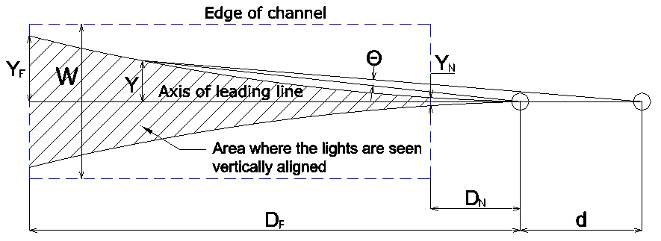 35

7.5.2. Maximum Intensity less than Minimum Intensity 35

7.5.3. Maximum Intensity less than Recommended Intensity 35

7.5.4. Compromises during Leading Line Design 36

8. supplemental INFORMATION 36

8.1. Lights 36

8.1.1. Fan versus Pencil Beam Lights 36

8.1.2. Beam Width of Pencil Beam Lights 36

8.1.3. Additional Lights 37

8.2. Daymarks versus Daytime Lights 37

8.3. Colour and Flashes 37

8.4. Tower Placement 38

8.5. Lantern Placement 38

8.6. Servicing Considerations 39

8.7. Construction Details 39

8.8. Safety 39

8.9. Daymark Mounting 39

8.10. Sensitivity of a Leading Line 39

9. references 40

10. Abbreviations and Technical Quantities 41

10.1. Roman 41

10.2. Greek 44

APPENDIX 1 SIMPLIFIED INTENSITY CALCULATION 46

List of Tables

**Es konnten keine Einträge für ein Abbildungsverzeichnis gefunden werden.**

List of Figures

Figure 1 Geometry of a leading line and its appearance for observer, when off centreline 7

Figure 2 Geometry of a leading line and its appearance for observer, when at centreline 7

Figure 3 Channel parameters (plan view) 9

Figure 4 Observer's parameters (plan view) 9

Figure 5 Vertical plane (side view) 10

Figure 6 Heights of lights and daymarks 10

Figure 7 Vertical Difference Angle () 16

Figure 8 'Apparent magnitude of front and rear light' 17

Figure 9 Horizontal difference angle 17

Figure 10 Bearing and elevation difference 18

Figure 11 Minimum height of front light considering an obstruction 21

Figure 12 Guideline 2001 Daybord Design 23

Figure 13 Comparison of recommended daymark lengths 24

Figure 14 U.S. Coast Guard Dayboard Dimensional Ratios 25

Figure 15 Alternative daymark colour codes (U.S. Coast Guard) 25

Figure 16 Alternative daymark shapes 26

Figure 17 Design process 28

Figure 18 Two range designs having the same CTF at the far end but different CTF at the near end 34

Figure 19 Beam Width of Leading Lights 37

Figure 20 Tower Placement 38

Figure 21 Required intensities when calculated with different input for V and E 46

Figure 22 Recommended Intensity for a meteorological visibility (red dotted line) 47

Figure 23 Luminous intensity of German leading lights 48

Figure 24 Recommended luminous intensity according to the simplifiedsimple method shown with blue curve… anything about the other curves, to text or in here? 49



# Introduction

A leading line is a straight line produced by the alignment of two fixed aids to navigation used to mark straight sections of fairways or channels. The aids to navigation producing a leading line can be daymarks or lights or consist of both and are called leads. For the remainder of this document the two navigational marks are referred to as the “front lead” and the “rear lead”. The part of the line intended for navigational use is called the “useful segment” of the leading line. The end closer to the front lead is called the “near end” and the end further from the front lead is called “far end” of the useful segment.

The design of a leading line has to consider:

* Geometric parameters and the layout of the leading line;
* The luminous intensity of the light and
* Dimensions of the daymark.

The performance of a leading line can only be guaranteed when all parameters work together. Therefore, extensive and iterative calculations are usually necessary. Figures 1 and 2 provide a general overview of the geometry of leading lines.



1. Geometry of a leading line and its appearance for observer, when off centreline



1. Geometry of a leading line and its appearance for observer, when at centreline

# Purpose

The purpose of this document is to provide guidance on the principles of leading lines and the calculation used in their design. Guidance on fairway design is provided in Guideline *G1078 The Use of AtoN in the Design of Fairways* (Ref)

# Background

Complete text from E-112 Annex 1, cannot be improved

Leading lines allow ships to navigate with precision along straight sections of a route. As a Marine Aid to Navigation they are reliable and simple to use providing visibility is sufficient to see the leading marks/lights..

It is therefore common practice to guide ships along narrow fairways by means of leading lights or, more generally, a series of leading lights in succession, the useful segments of which form a continuous series of straight lines. This is similar to the way the centrelines of artificial channels are laid out in a series of straight lines along which ships will be guided by leading lights. The availability of suitable sites for the leading marks may influence the selection of ship courses in natural, narrow fairways or in the layout of artificial channels.

In order to reach the useful segment of a leading line, it will often be necessary to observe the leading marks or lights whilst in a region to seaward or to the side of it. This region is called ~~the “~~acquisition region~~”~~.

To reach the useful segment of a leading line, it is necessary to observe both leading marks or lights while in a seaward region. This region is called the "acquisition region." Observing both marks or lights will allow the navigator to perform the maneuver with sufficient safety margin to properly navigate the channel. The size of the acquisition zone must be taken into account in the calculation of the main line (at least in terms of intensities and divergences).

Pärtel’s version: To be able to make the manoeuvres for reaching the leading line with sufficient safety margin the navigator/mariner/… has to see both leading marks or lights some distance before the farthest point of the useful segment of the leading line. The region where navigator has to be able to see both marks or lights when approaching a leading line is called “acquisition region/zone”.

When using a leading line, the determination of the “usable width of a channel” or of the axis to be marked in a natural channel for each particular case requires taking into account not only of the inaccuracy (sensitivity) of the relevant aid to navigation (leading linee), but also different 'nautical margins', such as those resulting from the breadth of ships, extra widths required for vessels to pass each other, the drift angle between the shipping route and the head of the ship when a ship is submitted to the effect of transverse winds and currents, uncertainties resulting from inaccuracies in hydrographic surveys or possible changes in the sea bottom since the last survey, etc.

This guideline is only related to the inaccuracy of the aid to navigation proper, leaving out the different 'nautical margins' that should be taken into account but which depend on local conditions and can only be determined after considering each particular case.

# History

Although leading lines play an important role for navigation in narrow channels, there was no internationally published design methodology or specification before 1998. The appearance and the design of leading lines is therefore very different at each nation.

The first standardization was published by IALA with Recommendation E-112 in 1998 e. The recommendation included basic requirements on the position, height and luminous intensity of leading lights. As a design methodology was missing, a spreadsheet program for leading line calculation was created and the manual for the use of the spreadsheet became IALA Guideline 1023 in 2001 [2]. In addition to the methodology from the Recommendation, ethe Guideline includes a methodologies for sizing daymarks. Both recommendation and guideline are mainly influenced by the standard design of the United States Coast Guard.

Since then, the IALA documents have been widely used for the design of new leading lines. However, many leadings lines were built long before 1998 and some nations still use their national design tools or specifications, when a leading line must be changed or newly built.

The present update of the 2001 guideline follows the idea of presentingpresent the various aspects, which should be looked at, when designing a leading line. The original procedure is still present, but explanations and discussions are given to enable the users to adapt their own methodologies to the IALA procedure.

# Definitions and Parameters

Variables required for the design of a leading line are described in this section. The channel is idealised to a horizontal rectangle, which is symmetrical about the centreline (see Figure 3).

The front lead is abbreviated FL and the rear lead is abbreviated RL.

SI Standard units are used:

* Lengths and heights in metres [$m$]
* Illuminance in lux [$lx$]
* Luminous intensity in candelas [$cd$])
* Angles are in radians, unless otherwise stated. In many cases the angles are small and therefore some approximations are valid ( and).

IHO Chart Specification [5] unit used are:

* Nautical mile () [ $1 M=1852 m$]





 All dimensions are named explicitly; for example, instead of writing $e^{x}$ the term $e^{x/{d_{U}}}$ is used. This will work for $x$ both in metres and in nautical miles: $e^{{1000 m}/{1 M}}=e^{{1000 m}/{1852 m}}= e^{{0,54 M}/{1 M}}=e^{0,54}$.

This is done for distance with $d_{U}=1 M=1852 m$, height $h_{U}=1 m$ and illuminance $E_{U}=1 lx$.

For all equations, SI units are used unless stated otherwise.

## Geometry, Plan View

* $C$ Length of useful segment
* $L$ Distance to front structure from far end to useful segment ($L=C+M$)
* $M$ Distance to front structure from near end to useful segment
* $R$ Distance between leading line structures
* $W$ Useful channel width



1. Channel parameters (plan view)

* $x$ Distance of observer (vessel) from front tower (parallel to leading line)
* $y$ Off-axis distance of observer (perpendicular to leading line)
* $θ$ Bearing difference (horizontal angular distance between front and rear light)



1. Observer's parameters (plan view)

## Geometry, Side View

The height of the observer on the vessel is referenced to both mean high water (MHW) and mean low water (MLW) at the vessel’s location along the useful segment. All other heights are referenced to MHW. Mean sea level ($MSL$) can be used in place of MHW or MLW when the mean tidal range (MTR) is small or zero ($MTR<0.3 m$).



1. Vertical plane (side view)

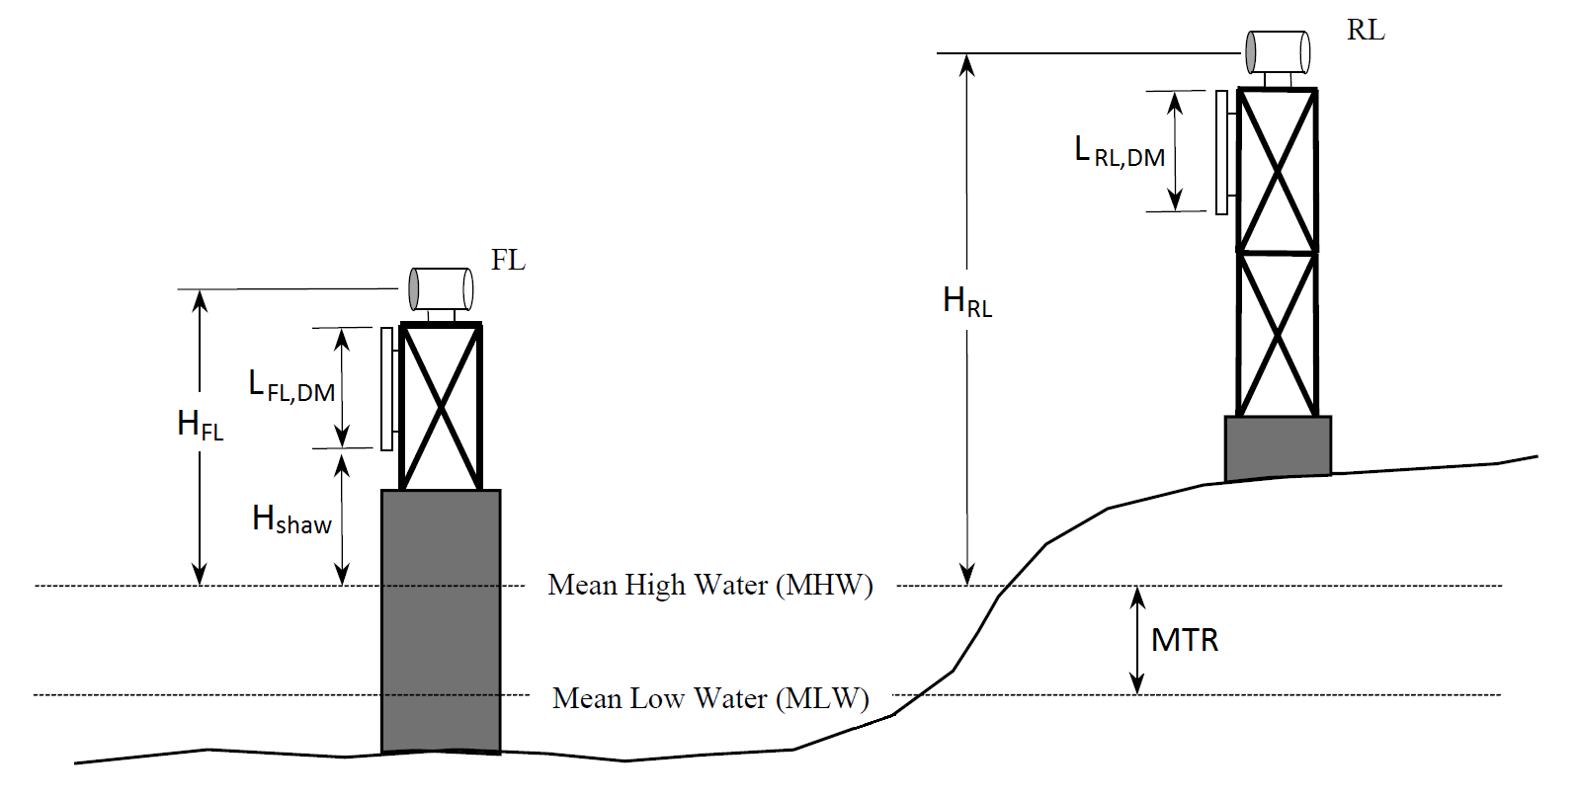

1. Heights of lights and daymarks

* $H_{v}$ Height of observer (on vessel) above vessel waterline
* $H_{FL}$ Height of front light above $MHW$ or $MSL$
* $H_{RL}$ Height of rear light above $MHW$ or $MSL$
* $H_{shaw}$ Safe height above water
* $L_{FL,DM}$ Vertical length of the front light daymark
* $L_{RL,DM}$ Vertical length of the rear light daymark
* $MHW$ Mean high water
* $MLW$ Mean low water
* $MSL$ Mean sea level
* $MTR$ Mean tidal range
* $Z_{FL}$ Height of front mark obscured behind earth’s curvature.
* $Z_{RL}$ Height of rear mark obscured behind earth’s curvature.
* $γ$ Vertical difference angle between front and rear light)

## General overview of design process

Throughout the leading line design process, the designer will calculate minimum and maximum values for parameters such as heights and luminous intensity which set the range of viable solutions. These minimum and maximum calculations will then lead to recommended value calculations. Once a recommended value is obtained, then a design value is selected. The design or selected value may be the recommended value or another value between the minimum and maximum values. The calculations provide a specific value that may not be practical, prudent or cost effective in constructing the leading line. For example, the recommended height of the front lead is 4.2 m. Instead, the designer selects a front lead height of 5 m which is a standard tower design for their nation. As design value are chosen, the calculations are completed with the design values to ensure the leading line system is effective.

## Luminous intensity calculations

Detailed information on the luminous intensity calculations needed for the design of leading lights can be found in IALA Guideline *G1148 Determination of Required Luminous Intensity for Marine Signal Lights* [1]. Based on this guideline the following parameters must be determined in the calculation of leading lights.

* $E_{FL}$ Illuminance at the eye of the observer produced by the front light
* $E_{RL}$ Illuminance at the eye of the observer produced by the rear light
* $E_{r}$ Required minimum illuminance at the eye of the observer  
  The required minimum illuminance at the eye of the observer depends on background lighting of the leading lights. $E_{r}={10}^{-6} lx$ is used for situations without background lighting, $E_{r}={10}^{-5} lx$ for minor and $E_{r}={10}^{-4} lx$ for substantial background lighting. For a daytime light the required illuminance is $E_{r}={10}^{-3} lx$.
* $E_{max}$ Allowed maximum illuminance at the eye of the observer  
  The allowed maximum illuminance at the eye of the observer is needed to avoid glare. $E_{max}=0.01 lx$ is used for situations without background lighting, $E_{max}=0.1 lx$ with background lighting. It is very unlikely to cause glare with daytime lights, so there is no need to check for and no maximum value for the illuminance is defined for daytime lights.
* $I_{FL}$ Luminous intensity of the front light
* $I_{RL}$ Luminous intensity of the rear light
* $V_{min}$ Minimum Meteorological Visibility

The minimum meteorological visibility should be based on the worst visibility conditions under which the leading lights must be usable. echosen by the designer depending on navigational requirements, practical limitations, etc. For guidance in selecting the optimal value for minimum meteorological visibility please refer to Guideline G1148.



* $V_{dsg}$ Design Meteorological Visibility  
  The design visibility was originally conceived as the median value of meteorological visibility for the site. That is, the value met or exceeded 50% of the time. Design visibility is used to establish the recommended ratio of luminous intensities of the front and the rear light. As a practical consideration, use of a fixed value $V_{dsg}=10 M=18 520 m$ is recommended.
* $V_{max}$ Maximum Meteorological Visibility  
  The potential for glare produced by the lights is calculated with the maximum meteorological visibility. Typically $V_{max}=20 M=37 040 m$ is chosen.

## OTHER TERMS

Some symbols are defined in individual chapters and their meaning is explained in the context. For these the following predefinitions are used.

* $DM$ indicates the use of daymarks (yes/no)
* $DTL$ indicates the use of daytime lights (yes/no)
* $E$ illuminance
* $H$ height
* $I$ luminous intensity
* $L$ (vertical) length of a daymark, distance from the front mark to the far end
* $r$ ratio
* $R_{g}$ geographical range
* range of a daymark
* $S$ distance between an obstruction and front light (parallel to centreline)
* $V$ visibility
* $W_{index}$ extension or width, when used with index, usually for the daymark
* $x$ distance (along to centreline)
* $y$ distance (perpendicular to centreline), off-axis distance
* $Z$ dip of horizon
* $α$ factor for dip calculation
* $ϕ$ angle used to describe horizontal divergence

The following indices are used.

* $DM$ daymark
* $d$ detection
* $dsg$ design
* $far$ far, referencing the far end of the channel
* $FL$ front light
* $initial$ initial iteration value
* $max$ maximum
* $mi$ d middle, referencing the middle of the channel
* $min$ minimum
* $min1, min2…$ minimum according to the requirement referenced
* $near$ near, referencing the near end of the channel
* $obs$ obstruction
* $rec$ recommended
* $RL$ rear light
* $sel$ selected
* $shaw$ safe height above water
* $v$ vessel, referencing the observer at the vessel

# Design equations

## LEADS Position

As a starting point, input values for the rectangular dimensions of the useful segment ($C, W$) must be defined.

When the locations of the leads (front and rear) are not prescribed by geographical or other restrictions the following formulas can be used for initial determination of their positions in relation to the channel to be marked.

Distance from the near end to the front tower: $M_{initial}=\frac{C}{5}=0.2∙C$ (1)

Distance between the towers:

$R_{initial}=\frac{\left(a+C\right)}{\left[1000*W/{\left(3.4∙\left(a+C\right)\right)-1}\right]}=\frac{L}{\left[\left(\frac{1000∙W}{3.4∙L}\right)-1\right]}$ where is the factor for calculation of dip of horizon(?) (2)

Explanation for $R_{initial}$:

For the calculation of the initial value of $R_{initial}$ it is assumed that the observer is able to detect that they are distance $Y_{D}=0.1∙W$ apart from the leading line at the far end of the useful segment. Furthermore, it is assumed that the elevation difference at this position is $γ=1.5∙{10}^{-3} rad$ ($≈5'$) and the bearing difference becomes $θ=0.34∙{10}^{-3} rad$.

## Luminous intensity

The intensity needs the input of a distance $x$, a visibility $V$ and a threshold for the illuminance $E$ at the eye of the observer and is calculated by Allard’s Law as follows:

$I=E∙x^{2}∙{0.05}^{-x/V}$ (3)

When an intensity is known, the illuminance at the eye of the observer is:

$E=I∙x^{-2}∙{0.05}^{x/V}$ (4)

### Minimum Luminous Intensity

The required minimum intensity of the front and rear lights is calculated for the minimum meteorological visibility (worst atmospheric condition), required illuminance at the eye of the observer and for the maximum distance from each tower to the far end of the useful segment. The minimum luminous intensity should be calculated for night and for day, if the lights are also to be used during daylight.

Minimum intensity (FL):

$I_{FL,min}=E_{r}∙{\left(M+C\right)}^{2}*{0.05}^{-{\left(M+C\right)}/{V_{min}}}$ (5)

Minimum intensity (RL):

 e

where $E_{r}$ minimum required illuminance at the eye of the observer

(1 micro lux for leading lights as per IALA Guideline *G1148 Determination of Required Luminous Intensity for Marine Signal Lights)*

$V_{min}$ minimum visibility

$M+C$ distance from far end of channel to front lead

$R+M+C$ distance from far end of channel to rear lead.

### Maximum Luminous Intensity

To avoid glare the luminous intensity should not exceed a certain maximum value. The maximum allowed intensity is calculated for both front and rear lights at the near end of the useful segment. In equations 13 and 14, e and are derived from G1148:

Maximum intensity of front light:

 (6)

Maximum intensity of rear light:

 (7)

where maximum illuminance at the observer

 maximum visibility

$M$ distance from near end of channel to front light

$R+M$ distance from near end of channel to rear light.

### Design Luminous Intensity of Front Light

The designer of the leading line may choose any intensity for the front light, as long as it is between the minimum and maximum value. The design luminous intensity should consider the presence of background lighting. G1148 provides alternative values of E to use in certain background lighting conditions.

### Design Luminous Intensity of Rear Light

The illuminances at the eye of the navigator provided by the respective lights within the useful segment should be as equal as possible. An intensity ratio is used to determine the design intensity of the rear light based on the design intensity of the front light. Allard’s law and the ideal ratio are used to determine the design luminous intensity of the rear light.

The illuminance values for the lights at the design visibility *Vdsg* e

$E_{FL}=I_{FL}∙x^{-2}∙{0.05}^{x/{V_{dsg}}}$ (8)

$E_{RL}=I_{RL}∙{\left(R+x\right)}^{-2}*{0.05}^{{\left(R+x\right)}/{V_{dsg}}}$ (9)

The ratio of illuminances is: $\frac{E_{FL}}{E_{RL}}=\frac{I_{FL}}{I_{RL}}∙\frac{{\left(R+x\right)}^{2}}{x^{2}}∙\frac{{0.05}^{x/{V_{dsg}}}}{{0.05}^{{\left(R+x\right)}/{V_{dsg}}}}=\frac{I_{FL}}{I_{RL}}∙\frac{{\left(R+x\right)}^{2}}{x^{2}}∙{0.05}^{{-R}/{V_{dsg}}}$

The ideal ratio for the illuminance should be equal to one, i.e., $\frac{E_{FL}}{E_{RL}}=1$ 00



However, the ratio depends on the observer's distance from the (front) light $x$. Since the ideal ratio can only be achieved at one location along the useful segment, it is recommended that the ratio $\frac{I_{RL}}{I_{FL}}$ be calculated at least twice, first for a position in the middle of the channel and secondly for a position at the far end.

These ratios are evaluated to determine a recommended ratio from which the rear light design luminous intensity is calculated. It is generally preferred to set the ratio to 1 at the far end provide a strong signal to the mariner in the acquisition range. The following factors should also be considered in setting the ratio and the corresponding selection of the rear light design luminous intensity

* For longer leading lines, it may be necessary to set the ratio to ratio to one at or closer to the middle of the useful segment to avoid glare or bluring of the lights at the near end.
* The size, volume and typers of maritime traffic should be considered in selection the location along the useful segment to set the ration to 1.
* As per *R0112 Leading Lights* Optimally, ratios between 0.5-2.0 range along the entire length of the leading line are optimal*.*

*In the leading lines spreadsheet, the ratio is calculated for every 10% increment of the useful segment length.*

*Middle of the channel:*

The distance from the middle of the channel to the front light (FL) is: $X_{FL,mid}=M+\frac{C}{2}$

the rear light (RL) is: $X_{RL,mid}=R+M+\frac{C}{2}$

With these equations the ratio becomes:

$$r_{mid}=\frac{I_{RL}}{I_{FL}}=\frac{{X_{RL,mid}}^{2}}{{X_{FL,mid}}^{2}}∙\frac{{0.05}^{{X_{FL,mid}}/{V_{dsg}}}}{{0.05}^{{X_{RL,mid}}/{V_{dsg}}}}=\frac{{\left(R+M+\frac{C}{2}\right)}^{2}}{{\left(M+\frac{C}{2}\right)}^{2}}∙{0.05}^{{-R}/{V_{dsg}}}$$

*Far end of the channel:*

The distance from the far end of the channel to the front light (FL) is: $X_{FL,far}=M+C$

the rear light (RL) is: $X_{RL,far}=R+M+C$

With these the ratio of intensities becomes:

$$r_{far}=\frac{I_{FL}}{I_{RL}}=\frac{{X_{FL,far}}^{2}}{{X_{RL,far}}^{2}}∙\frac{{0.05}^{{X_{RL,far}}/{V_{dsg}}}}{{0.05}^{{X_{FL,far}}/{V_{dsg}}}}=\frac{{\left(M+C\right)}^{2}}{{\left(R+M+C\right)}^{2}}∙{0.05}^{R/{V_{dsg}}}$$





During daylight the luminous intensity of a light needs to be magnitudes higher than at nighttime. This may result in complex lighting and power requirements. Therefore, design luminous intensity is not calculated for daytime lights. Instead, it is assumed that the design luminous intensity will be equal to or above the minimum luminous intensity.

## Vertical Difference Angle

It is important that the navigator observes an elevation difference between the lights at any point along the useful segment. A vertical angle is the angle of a light to the horizontal plane of the observer.

The vertical difference angle is the vertical angle between front and rear light seen from the observer. The vertical difference angle is calculated as the difference between the vertical angles of the front and rear light. For a leading line, the vertical difference angle plays an important role for correct design.

Vertical difference angles are calculated at MLW as this condition yield the smallest vertical difference angels which can affect the mariner’s ability to observe visible separation of the leads.

Equations 10 to 14 are derived with reference to Figure 7.

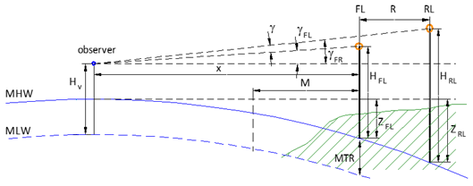

1. Vertical Difference Angle ($γ$)

At mean low water, the vertical angles are:

$γ_{FL}≈\tan{γ_{FL}=\frac{H_{FL}-Z_{FL}+MTR-H_{v})}{x}}$ (10)

$γ_{RL}≈tan{γ_{RL}=\frac{H_{RL}-Z_{RL}+MTR-H_{v}}{x+R}}$ (11)

At longer distances, the apparent height of a light above the horizon is reduced by the height of the mark that is obscured $\left(Z\right)$ by the earth’s curvature. The value of $Z$ depends on the distance $(x)$ between the observer and the light.

* $Z_{FL}≈α∙x^{2}$ (12)
* $Z_{RL}≈α∙{\left(x+R\right)}^{2}$ (13)

where $α=6.75∙{10}^{-8}m^{-1}$.

The vertical difference angle (vertical angle between front and rear light as seen from the observer) is then:

* $γ=γ_{RL}-γ_{FL}=\frac{H_{RL}-Z_{RL}-H_{v}+MTR}{x+R}-\frac{H_{FL}-Z_{FL}-H_{v}+MTR}{x}$ →
* $γ=\frac{H_{RL}-{α∙{\left(x+R\right)}^{2}-H}_{v}+MTR}{x+R}-\frac{H_{FL}-α∙x^{2}-H_{v}+MTR}{x}$ →
* $γ=\frac{H_{RL}{-H}_{v}+MTR}{x+R}-\frac{H_{FL}-H_{v}+MTR}{x}-α∙R$ (14)

where $α=6.75∙{10}^{-8}m^{-1}$.

The vertical difference angle will vary in practical use based on the current sea level, the observer height and the distance.

## Minimum Vertical Difference Angle

For navigating along a leading line, i.e. being able to notice deviation from the line, leading line (lights and daymarks) must appear vertically separated to the mariner, i.e. the rear light clearly above the front mark. There is a minimum value for the elevation difference, at which the lights are very close but can still be clearly seen as two separated lights.



The minimum required elevation difference) between the lights depends on the illuminance at the eye of the observer generated by the lights. In general, all maritime lights are seen under a viewing angle below the eye resolution (approx. $1^{'}={0.291∙10}^{-3}rad$). However, the lights appear larger or smaller for the observer's eye according to their brightness. (This effect is known from astronomy as the 'apparent magnitude (of a star).)



1. 'Apparent magnitude of front and rear light'

To account for that effect and calculate the minimum required difference $γ_{min}$ the luminous intensity of front and rear light must be selected.

* selected luminous intensity FL: $I_{FL,sel}$
* selected luminous intensity RL: $I_{RL,sel}$

The illuminance at the eye of the observer is then calculated for very good viewing conditions ($V_{max}=20 M$, $T_{max}=0.861$) and for the 10 equally spaced positions along the channel.

* illuminance from FL: $E_{FL}=I_{FL,sel}∙x^{-2}∙{0.05}^{x/{V_{max}}}$ (15)
* illuminance from RL: $E_{RL}=I_{RL,sel}∙{\left(x+R\right)}^{-2}∙{0.05}^{{\left(x+R\right)}/{V_{max}}}$ (16)

The minimum difference angle is then:

* $γ_{min}=\left[2.4-0.06∙\left|log\left({E_{RL}}/{E_{FL}}\right)\right|+0.26∙{\left|log\left({E_{RL}}/{E_{FL}}\right)\right|}^{2}+\log{\frac{E^{+}}{E_{U}}∙\left(0.2-0.02∙\left|log\left({E_{RL}}/{E_{FL}}\right)\right|-0.02∙{\left|log\left({E_{RL}}/{E_{FL}}\right)\right|}^{2}\right)}\right]∙{10}^{-3}rad$ (17)

where $E^{+}=\left\{\begin{matrix}max\left\{E_{FL},E_{RL}\right\} at nighttime \\ {max\left\{E_{FL},E_{RL}\right\}}/{10000} at daytime\end{matrix}\right\}$ and $E_{U}=1 lx$.



Generally, a $γ_{min}$ less than 1.5 leads to blurring and should be avoided.

## Horizontal Difference Angle

The horizontal angle describes the horizontal angle between the direction to a light from the observer and a line parallel to the leading line. The horizontal difference angle is the horizontal angle between front and rear light seen from the observer. The horizontal difference angle is calculated as the difference between the horizontal angles of the front and rear light. It depends on the horizontal distance of the vessel from the leading line.

The equations necessary for the calculations are derived from Figure 8.



1. Horizontal difference angle

From 9:

$θ_{FL}≈tan{θ_{FL}}{=\frac{y}{x}}$

$θ_{RL}≈tan{θ_{RL}=\frac{y}{x+R}}$

* $θ=θ_{FL}-θ_{RL}=\frac{y}{x}-\frac{y}{x+R}=\frac{y∙R}{x∙(x+R)}$ (18)

The off-axis distance is calculated as follows:

* (19)

## Sensitivity of a Leading Line

The sensitivity (or precision) of a leading line is the magnitude of the minimum value of the bearing difference $Θ_{D}$ of the two lights, when an off axis deviation in a definite direction is detectable with certainty by the observer.

Sensitivity) of a leading line is the magnitude of deviation from the leading line needed for an observer to detect with certainty that the lights are not vertically aligned. Off-axis distance shows absolute sensitivity, cross-track factor shows relative sensitivity compared to width of the channel. Smaller detection deviation has a higher sensitivity and larger detection deviation has a lower sensitivity.

Sensitivity of a leading line depends mostly on the distance between the leading marks (longer distance yields a higher sensitivity). To a smaller extent, the elevation difference of the lights/daymarks impacts the leading line sensitivity (the closer the lights/daymarks appear to each other vertically the higher the sensitivity).

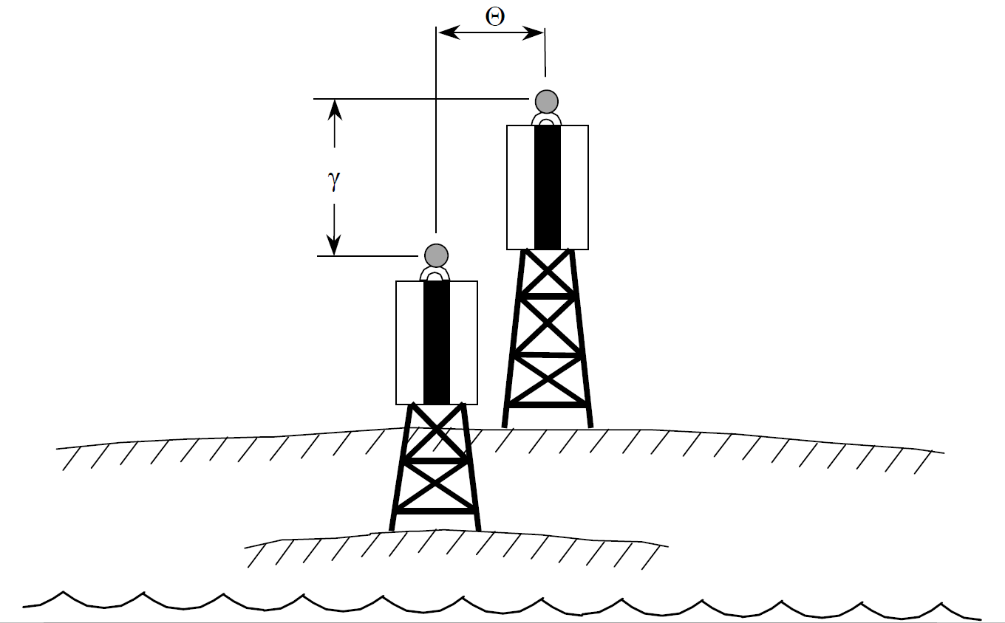

1. Bearing and elevation difference

Bearing difference for detection of not being on the leading line based on elevation difference $γ$ (vertical angle) is calculated using the formulae:

* (20)

where

* ${Θ'}_{1}=0.16∙{10}^{-3} rad+0.12*γ$ for $γ≤5∙{10}^{-3} rad$;
* ${Θ'}_{1}=0.31∙{10}^{-3} rad+0.09*γ$ for $5∙{10}^{-3}<γ≤20∙{10}^{-3} rad$;
* ${Θ'}_{2}=0.224∙γ_{min}$ (see 6.5).

Note: Prior to calculate $Θ_{d}$, $γ_{min}$ must calculated at MHW using the equations below:

* $γ=γ_{RL}-γ_{FL}=\frac{H_{RL}-Z_{RL}-H_{v}}{x+R}-\frac{H_{FL}-Z_{FL}-H_{v}}{x}$ →
* $γ=\frac{H_{RL}-{α∙{\left(x+R\right)}^{2}-H}_{v}}{x+R}-\frac{H_{FL}-α∙x^{2}-H_{v}}{x}$ →
* $γ=\frac{H_{RL}{-H}_{v}}{x+R}-\frac{H_{FL}-H_{v}}{x}-α∙R$ (21)

where $α=6.75∙{10}^{-8}m^{-1}$.

Ask Pärtel:

In Germany we have a different equation for sensitivity.

Are there others? Should we mention them?

## Cross-Track Factor

Cross-track factor $CTF$ is a measure of sensitivity of a leading line. The cross-track factor is calculated as the ratio of the distance the navigator can detect with certainty that the vessel is not on the leading line, divided by the half-width of the channel expressed as a percentage.

From equations (21) and (25) is:

* (22)

The $CTF$ then becomes: (23)

* (%)

For a leading line design, the cross-track factor varies with the observers position ( in the useful segment and the observer's height $H_{v}$. Cross-track factor are suitability assessments are provided in Table 1.

1. Cross_Track Factor Suitability Assessment

|  |  |  |
| --- | --- | --- |
| $$CTF$$ | **Suitability** | **Interpretation** |
| over 75% | Not Acceptable | Range must be improved or it will be unworkable. |
| 50% - 75% | Poor | Decrease the cross-track factor if physically possible. |
| 30% - 50% | Fair | Decrease the cross-track factor only if moderate cost involved. |
| 20% - 30% | Good | Decrease the cross-track factor only if little cost involved. |
| 15% - 20% | Very Good | Do not expend more funds to decrease the cross-track factor. |
| 10% - 15% | Excellent | The cross-track factor should not be less than 10% at the far end of the channel. |

## Geographical Range

The geographical range $R_{g}$ of a light or a daymark is calculated by the following equation.

* $R_{g}=2.03 d_{u}∙\left(\sqrt{\frac{H}{h_{U}}}+\sqrt{\frac{H_{v}}{h_{U}}}\right)$ (24)

where

* $H$: Height of the light or lower end of the daymark;
* $H_{v}$: Height of the observer on vessel;
* $h_{U}=1 m$: Unit for height;
* $d_{U}=1 M=1852 m$ Unit for distance (1 nautical mile).

Remark: Written with hidden dimensions, the equation is: $R_{g}=2.03∙\left(\sqrt{H}+\sqrt{H_{v}}\right)$.

When a required geographical range is given, then the minimum height of a light or a daymark achieving that range can be derived from:

* $H={\left(\frac{R_{g}}{2.03∙d_{U}}-\sqrt{\frac{H_{v}}{h_{U}}}\right)}^{2}∙h_{U}$ (25)

Remark: Written with hidden dimensions, the equation is: $H={\left({R_{g}}/{2.03}-\sqrt{H_{v}}\right)}^{2}$

## Heights

There are several requirements for the height of the front and rear lead. Each requirement leads to a different minimum required height in the form of $H_{light}≥H_{min}.$ Each minimum height resulting from individual requirements is given an index i to identify it according to its requirement. The height of the lights are significantly controlled by the minimum observer height $H_{v}=H_{v,min}$ for which the leading line is designed. It is assumed that for observer heights lower than $H_{v,min}$ that the leading line will not work for parts or all of the useful segment.

### Front Light

#### Safe Height above Water

To avoid damage from waves or vandals or obstruction by vegetation, the front light $H_{FL}$ has to be above a safe height above water ($H_{shaw}$):

* $H_{FL}≥{H_{FL,min1}=H}_{shaw}$. (26)

When a daymark with length $L_{FL,DM,sel}$ is used, the lower end of the daymark shall be above and the light above the upper end of the daymark: $H_{FL,lower_end_daymark}≥H_{shaw}$.

In this case the minimum front light height is:

* (27)

#### Geographical Range

The height of the front light above mean high water must be sufficient to be seen above the horizon i.e. its geographical range must exceed the distance from the front mark to the far end of the channel $R_{g}=M+C$.

* $H_{FL}≥H_{FL,min3}={\left(\frac{R_{g}}{2.03 d_{U}}-\sqrt{\frac{H_{v}}{h_{U}}}\right)}^{2}∙h_{U}$ (28)

When a daymark with length is used, the lower end of the daymark must be high enough above mean high water so that its geographical range exceeds the distance to the far end of the channel.

$$H_{FL,lower_end_daymark}={\left(\frac{R_{g}}{2.03 d_{U}}-\sqrt{\frac{H_{v}}{h_{U}}}\right)}^{2}∙h_{U}$$ When the light is positioned at the upper end of the daymark the daymark length must be added to the minimum front light height.

* (29)

#### Avoid Occlusion by Obstruction

When an obstruction is between the front light and the observer and it seems to be relevant for the visibility of the front light, a calculation is necessary to estimate whether the front light is occluded. The height $H_{obs}$ and the distance $S$ between the obstruction and front light are needed for this calculation. is only calculated for the observer at mean low water which is the worst case situation for obstruction..



1. Minimum height of front light considering an obstruction

From Figure 11, the minimum height of the front light $H_{FL,min}$ can be derived.

$\frac{H_{obs}-Z_{obs}-\left(H_{v}-MTR\right)}{x-M+S}=\frac{H_{FL,min}-Z_{FL}-\left(H_{v}-MTR\right)}{x}$

$H_{FL,min}=\frac{x}{x-M+S}∙\left(H_{obs}-Z_{obs}-H_{v}+MTR\right)+Z_{FL}+H_{v}-MTR$

The dip of horizon for obstruction and front light is:

* $Z_{obs}=α∙{\left(x-M+S\right)}^{2}$ and $Z_{FL}=α∙x^{2}$ where $α=6.75∙{10}^{-8}m^{-1}$.

This leads to a minimum height for the front light: considering presence of an obstruction.

$H_{FL,min}=\frac{x}{x-M+S}∙\left(H_{obs}-H_{v}+MTR\right)+H_{v}-MTR-α∙x∙\left(x-M+S\right)+α∙x^{2}$

$H_{FL,min}=H_{v}-MTR+\frac{x}{x-M+S}∙\left(H_{obs}-H_{v}+MTR\right)+α∙x∙\left(M-S\right)$

The equation is used for $x=M+C$ (far end) and $x=M$ (near end) for the lowest height of eye $H_{v,min}$.

* Far end: $H_{FL,min5}=H_{v,min}-MTR+\frac{M+C}{C+S}∙\left(H_{obs}-H_{v}+MTR\right)+α∙\left(M+C\right)∙\left(M-S\right)$ 
   (30)
* Near end: $H_{FL,min6}=H_{v,min}-MTR+\frac{M}{S}∙\left(H_{obs}-H_{v}+MTR\right)+α∙M∙\left(M-S\right)$ 
   (31)

When the front light has a daymark with length, it is assumed that the lower end of the daymark must not be obstructed and that the light will be at the upper end of the daymark. In this case the selected height of the daymark $L_{FL,DM,sel}$ is added to the minimum front light height.

* Far end: $H_{FL,min7}={L_{FL,DM,sel}+H}_{v,min}-MTR+\frac{M+C}{C+S}∙\left(H_{obs}-H_{v}+MTR\right)+α∙\left(M+C\right)∙\left(M-S\right)$ 
   (32)
* Near end: $H_{FL,min8}={L_{FL,DM,sel}+H}_{v,min}-MTR+\frac{M}{S}∙\left(H_{obs}-H_{v}+MTR\right)+α∙M∙\left(M-S\right)$ 
   (33)

#### Selected Front Light Height

The recommended minimum height $H_{FL,rec}$ is the maximum value of the minimum heights calculated above. With this value, all requirements stated before in this chapter are fulfilled.

However, a different value for the height may be chosen, which is called $H_{FL,sel}.$

### Rear Light

The calculation of the rear light height requires that the front light height has already been selected ($H_{FL,sel}$).

#### Blur

The rear light must be high enough so that the elevation difference in whole useful segment is larger than $γ_{min}$ (Section 6.5), to avoid blur(ring?) of the lights.

$γ_{min}=\frac{H_{RL}{-H}_{v}+MTR}{x+R}-\frac{H_{FL,sel}-H_{v}+MTR}{x}-α∙R$

$H_{RL,min}=\left(x+R\right)∙\left(γ_{min}+\frac{H_{FL,sel}-H_{v}+MTR}{x}+α∙R\right)+H_{v}-MTR$

The minimum height of the rear lead considering blur is calculated for $x=M+C$ (far end) and $x=M$ (near end) for the lowest height of eye $H_{v}$.

* Far end: $H_{RL,min1}=\left(M+C+R\right)∙\left(γ_{min}+\frac{H_{FL,sel}-H_{v}+MTR}{M+C}+α∙R\right)+H_{v}-MTR$ 
   (34)
* Near end: $H_{RL,min2}=\left(M+R\right)∙\left(γ_{min}+\frac{H_{FL,sel}-H_{v}+MTR}{M}+α∙R\right)+H_{v}-MTR$ 
   (35)

#### Geographical Range

From blur calculation, which includes the dip of horizon resulting from the curvature of the Earth, it is guaranteed that the rear light will always appear above the horizon as well. So there is no need to check the rear light for geographical range. However, for the list of lights and the charts the geographical range of the rear light may be calculated separately.

#### Front Light not obscuring Daymark of Rear Light

At the far end of the channel ($x=M+C$) the entire daymark area of the rear light must appear above the front light.

* Far end: $$H_{RL,min3}=L_{RL,DM,sel}+H_{v}-MTR+\left(M+C+R\right)∙\frac{\left(H_{FL,sel}+MTR-H_{v}\right)}{M+C}+α∙\left(M+C+R\right)∙R$$ 
   (36)

At the near end of the channel ($x=C$) it is not necessary that the entire daymark is visible, because it appears much larger to the observer. An accepted compromise is that one half of the rear light daymark is visible above the front daymark.

* Near end: $H_{RL,min4}={\frac{1}{2}∙L}_{RL,DM,sel}+H_{v}-MTR+\left(M+R\right)∙\frac{\left(H_{FL,sel}+MTR-H_{v}\right)}{M+C}+α∙\left(M+R\right)∙R$  
   (37)

#### Avoiding Occlusion by Obstruction, without Daymark

The equations for the front light (6.9.1.3) are valid for the rear light with the following transitions:

* $H_{FL,min}$ → $H_{RL,min}$
* $M$ → $M+R$

This leads to:

$H_{RL,min}=H_{v}-MTR+\frac{x}{x-M-R+S}∙\left(H_{obs}-H_{v}+MTR\right)+α∙x∙\left(M+R-S\right)$

* Far end: $H_{RL,min5}=H_{v}-MTR+\frac{M+R+C}{C+S}∙\left(H_{obs}-H_{v}+MTR\right)+α∙\left(M+R+C\right)∙\left(M+R-S\right)$ 
   (38)
* Near end: $H_{RL,min6}=H_{v}-MTR+\frac{M+R}{S}∙\left(H_{obs}-H_{v}+MTR\right)+α∙\left(M+R\right)∙\left(M+R-S\right)$ 
   (39)

#### Avoiding occlusion by obstruction, with daymark

At the far end of the channel ($C+M+R$) the entire daymark area of the rear light must appear above the obstruction. In this case the full height of the daymark is added to the minimum rear light height.

* Far end: $H_{RL,min7}=L_{RL,DM,sel}+H_{v}-MTR+\frac{M+R+C}{C+S}∙\left(H_{obs}-H_{v}+MTR\right)+α∙\left(M+R+C\right)∙\left(M+R-S\right)$ 
   (40)

At the near end of the channel ($x=M$) it is not necessary that the entire daymark is visible, because it appears much larger to the observer. An accepted compromise is that one half of the rear light daymark is not obscured by the obstruction.

* Near end: $H_{RL,min8}={\frac{1}{2}∙L}_{RL,DM,sel}+H_{v}-MTR+\left(M+R\right)∙\frac{\left(H_{FL,sel}+MTR-H_{v}\right)}{M+C}+α∙\left(M+R\right)∙R$ 
   (41)

#### Selected Rear Light Height

The recommended minimum height is the maximum value of the heights calculated before. With this value, all requirements stated before in this chapter are fulfilled.

However, a different value for the height may be chosen, which is called $H_{RL,sel}.$

## Daymarks

The size of a daymark depends on its required visual range ($D_{DM})$: the longer the useful segment, the greater the size of the daymark. When considering geometry only, the dimensions (length $L_{DM}$ or width $W_{DM}$) of a daymark should be proportional to the required range: $L_{DM}\sim D_{DM}$ and $W_{DM}\sim D_{DM}$.

### Daymark Sizing Methodology

Tthe atmosphere will reduce the contrast of daymarks for long ranges according to 'Koschmieder's law'. The loss of contrast will reduce the range of the daymark. This can be compensated by increasing the daymarks size with an exponential function of the daymark range: $L_{DM}\sim exp\left(D_{DM}\right)$ and $W_{DM}\sim exp\left(D_{DM}\right)$.















1. Guideline 2001 Daybord Design



### Size Calculation

The size may be based on geometrical calculation.

This can be done with the tools of IALA guideline 1094 Daymarks for Aids to Navigation.

According to this guideline a daymark should appear with a minimum vertical subtense angle of 3' (0.873 mrad) at the far end of the channel. For better conspicuity, the value may be doubled (6' = 1.745 mrad), which is near to the recommended value of topmarks for buoys (IALA 1983).

The recommended height for the daymarks are therefore

* Required subtense angle 3': $L_{DM,rec}=0.873∙{10}^{-3}∙X$  
   (minimum IALA requirement) (42)
* Required subtense angle 6': $L_{DM,rec}=1.745∙{10}^{-3}∙X$  
   (enhanced daymark conspicuity) (43)
* Required sbtense angle 1’



where

* $X=X_{FL,far}$ for front light and
* $X=X_{RL,far}$ for rear light.

The recommended daymark lengths according to the 3’ and 6’ calculation methods are shown in Figure 13. Black dash and dot line shows required length of a daymark with 3’ subtense angle depending on the required range, black dashed line shows the same for 6’ subtense angle and the coloured lines show dependence of required length of a daymark from visibility and the range.

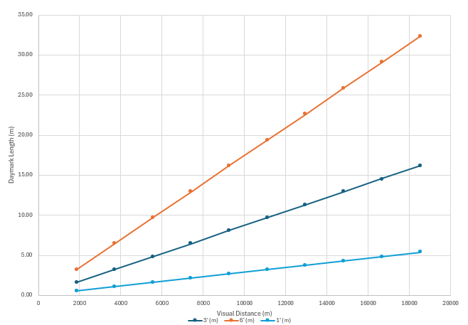

1. Comparison of recommended daymark lengths



Practical Sizing Considerations

* The 3’ method practical for most leading light designs.
* The 6’ method may be preferred to provide a larger signal to the mariner in areas of reduced visibility or other factors.
* The 1’ method may be suitable when daymarks are required to enable acquisition at the far end of very long leading lights. The smaller may not allow full use of the daymark without the use of binoculars..
* The maximum length of a daymark with guideline 2001 dimension is approximately 12 m.
* While providing a better signal to the mariner, larger daymarks require taller and stronger towers which will increase construction costs.

### Alternative Daymark Designs

The shape and the colour of a leading line daymark is not restricted by the IALA Maritime Buoyage System (MBS). Competent authorities may chosoe different designs according to their own experience/preference, but rectangular and triangular shapes are recommended by MBS.

In any case, it is advised to choose the vertical length of the daymark with the tools provided in chapter 6.10.1 or 6.10.2.

#### Length Width Ratio

The recommended daymark width is; however, s is also used.

A common ratio length and width of the center area is $L_{DM}/8$ only.



1. U.S. Coast Guard Dayboard Dimensional Ratios

#### Colours

When a series of leading lines are used, different colors should be used to ensure positive identification of each set of leading lines.



1. Alternative daymark colour codes (U.S. Coast Guard)

The colours chosen may also increase the contrast to a specific background. White outer bars often produce a good contrast to forest or rock as background, whereas black may be preferred when the sky or horizon is the background.

#### Shapes

Many nations use non-rectangular shapes for the daymark. in some cases theThe shape of front and rear daymark are mirrored. Some nations use stripes in 'nun-shape' and some nations use equilateral triangles.



1. Alternative daymark shapes

#### Retroreflectors on Daymarks

Some nations use retroreflective sheets for the daymark. The retroreflective materials replaces the light for night time use, however, with a much shorter useful segment. So at night time, the mariner needs to illuminate the front and rear daymarks with a searchlight to use the leading line.

More information is given in IALA Guideline G1145 Application of Retroreflecting Material on AtoN.

Finnish guidance about reflectors:

Reflectors are used as a substitute for lights at small craft routes and other less important fairways. They can be useful for other fairways too in case of damaged lights. The leading line still functions when used with a search light. Small crafts are assumed to have search lights with intensity of ca 10 000 cd and larger vessels search lights with 100 000 cd.

Minimal area of the reflector is found with the formula



Converted for illumination in the observer’s eye



A – area of the reflector, m2

E – threshold of the illumination at the eye, lx

d – viewing distance, m

I – intensity of the search light, cd

R – reflectivity of the retroreflector, lx/m2/cd

In principle the calculations are made as for lights, but as the problem is getting high enough reflection, maximum intensity is not calculated. The reflectors are positioned so that it covers ¾ of the middle stripe so it covers ¼ of the total area of the dayboard. Reflector of the front mark starts from the lower edge of the dayboard and reflector of the rear mark from the upper edge of the dayboard (to avoid blurring of the reflectors degrading usability of the leading line. Reflection diminishes fast with the distance. Even with high light intensities and large reflectors the largest usable distances are ca 4000 m but practical ranges are 0 …. 2500 m. For best possible reflection the reflector is always white. When the areas of the reflectors are determined, the final values of E are calculated for both marks.

Ask Pärtel: Put in here alternative designs and size calculations?

# Design Methodology

The design process is illustrated in Figure 17. A spreadsheet for calculatingconsidering the geometric and photometric parameterslayout of leading lines is provided by IALA. This chapter describes using the spreadsheet for these calculations.

In case positions of the leading marks are not already defined by any restrictions the calculationsThe calculation should start with an initial (preliminary) assessment of the tower positions at the worksheet “A Initial input” of the spreadsheet according to chapter 6.1. The initial input for this are the dimensions of the channel.

From then on, the design methodology is ‘trial'trial and error’, that means that the designer defines input parameters and looks whether the output gives suitable results. When problem codes are displayed orWhen the results are not suitable for other reasons the input has to be changed until all results are acceptable (iteration loop). The result is a complete geometric (distances, dimensions) and photometric (light intensities) layout. For identification the inputs are numbered with a prefix “**#**”,"**#**", the outputs with “**%**”"**%**" and the checks with “**§**” in the spreadsheet."**§**".



1. Design process

When a daytime light is considered the design process will be repeated for daytime.

Besides the considerations described here a complete geometric and photometric layout should also be monitored concerning practical design considerations. This may include optimisation of cost/benefit ratio, maintenance, construction and power requirements. If the calculated layout is not suitable because of practical design considerations, alternative markings or channel sizes should be regarded. This may also lead to a new leading line calculation with a different channel layout.

## Preliminary Assessment of Tower Positions

TheThis calculation on the first worksheet “A Initial input” gives a first hint to suitable tower positions. It should be checked immediately whether these positions are available, before running through the rest of the process. When the positions are not available, nearby positions, which are available can be used for the first step of the iteration loop. The calculations are based on chapter 6.1.

## Iteration Input Parameters

After a preliminary assessment of the tower positions the next step is to input all necessary parameters for a complete calculation on the next worksheet “B Leading line”.. The input parameters are:

* $DTL$ Use of daytime lights $DTL=yes / no$ (input #1)
* $C$ Length of channel (input #2)
* $W$ Width of channel (input #3)
* $MTR$ Mean tidal range (input #4)
* $E_{r}$ Background lighting (input #5)
* none: $E_{r}={10}^{-6} lx$
* minor: $E_{r}={10}^{-5} lx$
* substantial: $E_{r}={10}^{-4} lx$
* $H_{v}$ Height of the observer’s eye (at vessel) (input #6)
* $V_{min}$ Minimum Visibility (input #7)
* $V_{dsg}$ Design Visibility (standard is 10 M) (input #8)
* $V_{max}$ Maximum Visibility (standard is 20 M) (input #9)
* $R$ Distance between front and rear light (input #10)
* $M$ Distance between front light and near end of channel $M$ (input #11)
* $H_{shaw}$ Safe height above water (input #12)
* $DM$ Daymarks to be used? (input #13)
* $S$ Optional: Position from near end of channel to obstruction (input #14)
* $H_{obs}$ Optional: Height of obstructions (input #15)
* $L_{FL,DM,sel}$ Optional: Selected front daymark length (input #16)
* $L_{RL,DM,sel}$ Optional: Selected daymark length of rear light (input #17)
* $I_{FL,sel}$ Selected luminous intensity of front light (input #18)
* $I_{RL,sel}$ Selected luminous intensity of rear light (input #19)
* $H_{FL,sel}$ Selected height of front light (input #20)
* $H_{RL,sel}$ Selected height of rear light (input #21)
* Calculation method for recommended luminous intensity (input #22)
* Calculation method for daymark length (input #23)
* Factor for geographical range (input #24)

All calculations should be done for minimum and maximum observer height of eye $H_{v}$.

## Iteration Results

### Daymark Size (optional)

* $L_{FL,DM,rec}$ Front light, recommended daymark length (output %1)
* $W_{FL,DM,rec}$ Front light, recommended daymark width (output %2)
* $L_{RL,DM,rec}$ Rear light, recommended daymark length (output %3)
* $W_{RL,DM,rec}$ Rear light, recommended daymark width (output %4)

Calculation is based on chapter 6.10.

### Minimum Intensity

* $I_{FL,min}$ Minimum intensity of front light (output %5)
* $I_{RL,min}$ Minimum Intensity rear light (output %6)

Calculation is based on chapter 6.2.1.

### Recommended Intensity

* $I_{FL,rec}$ Recommended intensity front light (output %7)
* $I_{RL,rec}$ Recommended Intensity rear light (output %8)

Calculation is based on chapter 6.2.2.

### Maximum Intensity

* $I_{FL,max}$ Maximum intensity front light (output %9)
* $I_{RL,max}$ Maximum Intensity rear light (output %10)

Calculation is based on chapter 6.2.4.

### Intensity Ratio

* $r$ Recommended intensity ratio between front and rear light (output %11)
* ${I_{RL,sel}}/{I_{FL,sel}}$ Intensity ratio for selected intensities (output %12)

Calculation is based on chapter 6.2.2.

### Recommended Heights

* $H_{FL,rec}$ Recommended minimum height of front light (output %13)
* $H_{RL,rec}$ Recommended minimum height of rear light (output %14)

Calculation is based on chapter 6.9. The recommended height is the maximum value of all calculated minimum heights, so therefore all requirements are fulfilled.

### Illuminance at the Eye of the Observer

The illuminance at the eye of the observer produced by front and rear light should be calculated at various distances and meteorological visibilities.

* $E_{FL,min}\left(x\right)$ Front light, minimum visibility (output %15)
* $E_{FL,dsg}\left(x\right)$ Front light, design visibility (output %16)
* $E_{FL,max}\left(x\right)$ Front light, maximum visibility (output %17)
* $E_{RL,min}\left(x\right)$ Rear light, minimum visibility (output %18)
* $E_{RL,dsg}\left(x\right)$ Rear light, design visibility (output %19)
* $E_{RL,max}\left(x\right)$ Rear light, maximum visibility (output %20)

Calculation is based on chapter 6.2. When the luminous intensities are fixed ( $I_{FL,sel}$ and $I_{RL,sel}$), the illuminance should be checked all inside the channel.

### Minimum Elevation Difference

* $γ_{min}$ Minimum elevation difference (output %21)

The minimum elevation difference $γ_{min}$ is connected with height ofto the observer height and it should be checked all inside the channel.

Calculation is based on chapter 6.5.

### Cross-Track Factor

* $CTF$ Cross-Track Factor (output %22)

The cross-track factor $CTF$ should be checked all inside the channel against the Table 1. Calculation is based on chapter 6.7.

The $CTF$ is the final value to benchmark the leading line function.

## Iteration Assessment

The parameters of the leading line during iteration process need to be checked according to the requirements and to decide, when the iteration can be stopped.

For some results, the assessment should be done for many observer's positions inside the channel. Some output is information for the leading line designer only and does not need to be tested.

### Blur Test

The elevation angle should be equal or greater than the minimum elevation angle.

* (check §1)

Elevation angle see chapter 6.3, minimum elevation angle see chapter 6.5.

### Cross-Track Factor

The cross-track factor should be acceptable for? the mariner and must not be greater than 75%.

* $CTF ≤75\%$ (check §2)

### Brightness of Front Light

The illuminance at the eye of the observer produced by the front light $E_{FL,min}$ should be greater than the required illuminance $E_{r}$.

* $E_{FL,min}≥E_{r}$ (check §3)

It needs to be checked at the far end of the channel only.

### Brightness of Rear Light

The illuminance at the eye of the observer produced by the rear light $E_{RL,min}$ should be greater than the required illuminance $E_{r}$.

* $E_{RL,min}≥E_{r}$ (check §4)

It needs to be checked at the far end of the channel only.

### Glare Test for Front Light

The illuminance at the eye of the observer produced by the front light $E_{FL,max}$ should be smaller than the maximum illuminance $E_{max}$.

* $E_{FL,max}≤E_{max}$ (check §5)

It needs to be checked at the near end of the channel and for nighttime only.

### Glare Test for Rear Light

The illuminance at the eye of the observer produced by the rear light $E_{RL,max}$ should be smaller than the maximum illuminance $E_{max}$.

* $E_{RL,max}≤E_{max}$ (check §6)

It needs to be checked at the near end of the channel and for nighttime only.

### Check Daymark Size Front Light

The range of the daymark of the front light $D_{DM,FL}$ (see chapter 6.10) should be equal or greater than the distance to the far end of the channel.

* $D_{DM,FL}≥M+C$ (check §7)

### Check Daymark Size Rear Light

The range of the daymark of the rear light $D_{DM,RL}$ (see chapter 6.10) should be equal or greater than the distance to the far end of the channel.

* $D_{DM,RL}≥R+M+C$ (check §8)

### Rear Light above Front Light considering Blur

The rear light should appear above front light with the minimum elevation angle (see 6.9.2.1). (check §9)

Far end:



$H_{RL,sel}≥H_{RL,min1}$

Near end:

$H_{RL,sel}≥H_{RL,min2}$

### Front Light above Safe Height above Water

* The light or daymark should be above safe height above water (see 6.9.1.1).

Without daymark:

* $H_{FL,sel}≥H_{FL,min1}$ (check §10)

With daymark:

* $H_{FL,sel}≥H_{FL,min2}$ (check §15)

### Front Light above Horizon

The light or daymark should appear above horizon (see 6.9.1.2).

Without daymark:

* $H_{FL,sel}≥H_{FL,min3}$ (check §11)

With daymark:

* $H_{FL,sel}≥H_{FL,min4}$ (check §14)

### Obstruction not obscuring Front Light

The light should appear above obstruction (see 6.9.1.3). (check §12)

Far end:

${H_{FL,sel}≥H}_{FL,min5}$

Near end:

${H_{FL,sel}≥H}_{FL,min6}$

### Obstruction not obscuring Rear Light

The rear light should appear above the obstruction (see 6.9.2.4). (check §13)

Far end:

$H_{RL,sel}≥H_{RL,min5}$

Near end:

$H_{RL,sel}≥H_{RL,min6}$

### Obstruction not obscuring Front Daymark

The entire daymark should appear above the obstruction (see 6.9.1.3).

Far end:

* ${H_{FL,sel}≥H}_{FL,min7}$ (check §18 / § 20)

Near end:

* ${H_{FL,sel}≥H}_{FL,min8}$ (check §18 / §20)

### Front Light not obscuring Rear Daymark

At the far end the entire rear daymark should appear above front light (see 6.9.2.3).

* $H_{RL,sel}≥H_{RL,min3}$ (check §16)

At the near end the upper half of the rear daymark should appear above front light (see 6.9.2.3).

* $H_{RL,sel}≥H_{RL,min4}$ (check §17)

### Obstruction not obscuring Rear Daymark

At the far end the entire rear daymark should appear above the obstruction (see 6.9.2.5).

* $H_{RL,sel}≥H_{RL,min7}$ (check §19 / § 21)

At the near end the upper half of the rear daymark should appear above the obstruction (see 6.9.2.5).

* $H_{RL,sel}≥H_{RL,min8}$ (check §19 / §21)

## Final Leading Line Design

The iteration process may not result in a design that fulfils all requirements. Therefore it may be necessary to start with other initial positions or to look for alternative markings. In any case the design should be checked for the properties below.

### Lateral Sensitivity

#### Cross-Track Factor

The cross-track factor $CTF$ is the most important value to benchmark the leading line function. It is calculated with the sensitivity equation for $Θ_{D}$ (see chapter 8.10)

The $CTF$ is defined to be a ratio of the lateral distance at which a mariner can detect with certainty that a vessel is not on the leading line, divided by half the useful segment width, and expressed as a percentage.

A $CTF$ of 25% indicates that a mariner may be as far as 25% of the way towards the edge of the channel, when he can detect, with certainty, that he is off centreline. When using $CTF$ as an expression of lateral sensitivity, a higher $CTF$ implies a lower sensitivity and vice versa.

#### Evaluation of Acceptable Cross-Track Factors.

Table 1 in chapter 6.7 provides guidelines on the description and acceptability of various cross-track factors. Instead of setting upper (%) limits on the $CTF$, the designer should weigh the nautical margins available against the risk that passing vessels will be overly confined (a small $CTF$ (%) may result in increased risk of collision between passing vessels).

* If the $CTF$ at the far end is adequate, chances are good that the $CTF$ at the near end is much smaller. If there are marks at the turning point at the near end, they will allow the mariner to judge the edge of the channel, and the small $CTF$ may be of no concern.
* When a small $CTF$ is a problem, the range design can be modified to have an identical $CTF$ at the far end, but the $CTF$ at the near end will not be as small. Figure 18 illustrates the situation where the $CTF$ at the far end is identical, but the $CTF$ at the near end varies with the two designs. By moving the range structures back from the near end of the channel and increasing M and R, the $CTF$ at the near end is increased while keeping the $CTF$ at the far end the same.

#### Range Design Selection

Usually the range shown on the bottom of Figure 18 will give better service because the cross-track factor does not vary as much between the near and far ends, and the illuminance produced by each light on the eye of the user will be more nearly equal along the entire length of the channel. On the other hand this design might require larger dayboards, taller towers, or lights of increased intensity. It is up to the range designer to select the design that is most appropriate for the given situation.

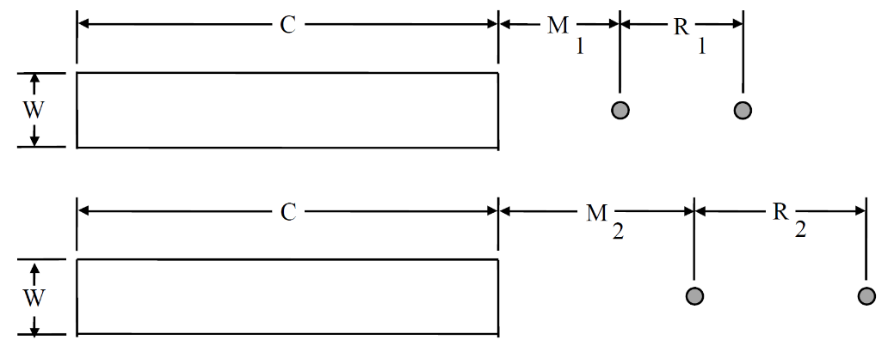

1. Two range designs having the same CTF at the far end but different CTF at the near end

### 

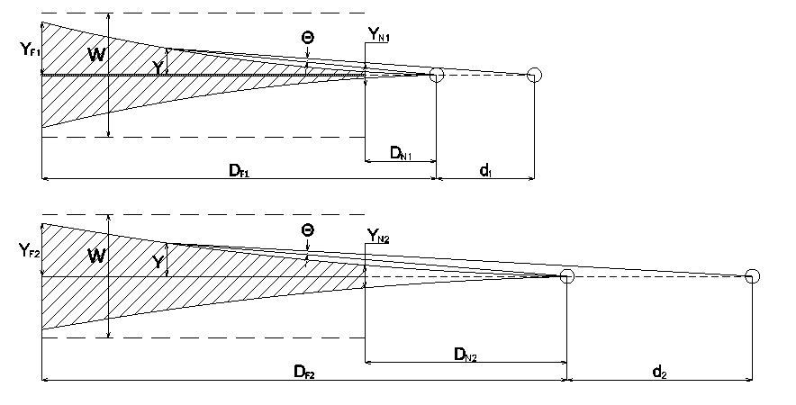

### Maximum Intensity less than Minimum Intensity

This situation arises when one or both leading lights (usually the FL) are too close to the channel, creating a glare problem. The best solution is to move the leading lights back from the near end of the channel, increasing M, until the situation is resolved. If that is not possible, then choose a light signal that provides the Minimum Intensity, to alleviate the glare situation as much as possible. Another way to reduce glare is to set the focal heights of the lights so as to be significantly different from the primary $H_{v}$ for vessels using the channel. This may result in the user being out of the primary portion of the beam, resulting in a reduction in intensity as the vessel approaches the near end of the channel.

### Maximum Intensity less than Recommended Intensity

This problem is similar to that described above, except that the Minimum Intensity does not result in glare. It is still generally best to move the leading lights back from the near end of the channel, thereby allowing selection of the Recommended Intensity. If that is not possible, than select an intensity between the Minimum and Maximum Intensities for the constrained leading light. The intensity for the other light should be selected to try and match the recommended ratio of intensities, so as to provide a good balance of illuminances. Note that in some instances this may result in the selected intensity for the RL being less than the Minimum Intensity. The leading line designer must find compromise between the intensity requirements and the recommended ratio of illuminance to optimize marking of the channel.

### Compromises during Leading Line Design

There is no single correct design for a given leading line. There are multiple successful combinations of optics, lamps, structure locations, optic heights, flash characteristics, colours, etc. With all the different designs possible for a given leading line, there comes a point where the designer must select which design to use. Selecting the design that optimizes the cost/benefit ratio for marking a channel is a trial and error process that requires practice. The selection criteria may include cost of construction, maintenance, cross-track factor, off-axis distance, tower heights, power requirements, $H_{v}$ of primary user, and user input. This is just a partial list, but indicates that design of a leading line is more of an art than a science.

# supplemental INFORMATION

## Lights

### Fan versus Pencil Beam Lights

The lanterns of a leading line may consist of fan or pencil beam lights. Fan beam lights (large horizontal beam width) or omnidirectional lights are preferred when the required ranges are small and when the light should be visible far outside the channel centreline. The use of omnidirectional lanterns also precludes the requirement for passing lights on towers located in navigable waters.

However, an omnidirectional light needs much more energy and may cause glare, when vessels are passing. In this case, it is better to choose pencil beam lights

### Beam Width of Pencil Beam Lights

There is often confusion regarding the effect of a narrow spread lens on the sensitivity of a leading line. The beam width of the optic has nothing to do with the lateral sensitivity of a leading line. The beam width is of some concern when a narrow spread lens is used, as care must be taken to ensure that the minimum intensities identified as necessary are provided over the full width of the far end of the channel. The angle that need to be subtended at the far end of the useful segment $ϕ$, (see Figure 19) is given by:

* $ϕ≈\frac{W}{X}$ (52)

where: $ϕ$ in rad;

$X$ distance from the light to the far end of the channel in metres; and

$W$ the width of the channel in metres.

Remark:

* Written in degree, the equation is: $ϕ \left(in degree\right)≈\left(\frac{57,3 degree}{radian}\right)∙\frac{W}{X}$
* The equation is used for front light (position $X_{FL,far}$) and rear light (position $X_{RL,far}$), which result in two different values $ϕ_{FL}$ and $ϕ_{RL}$.

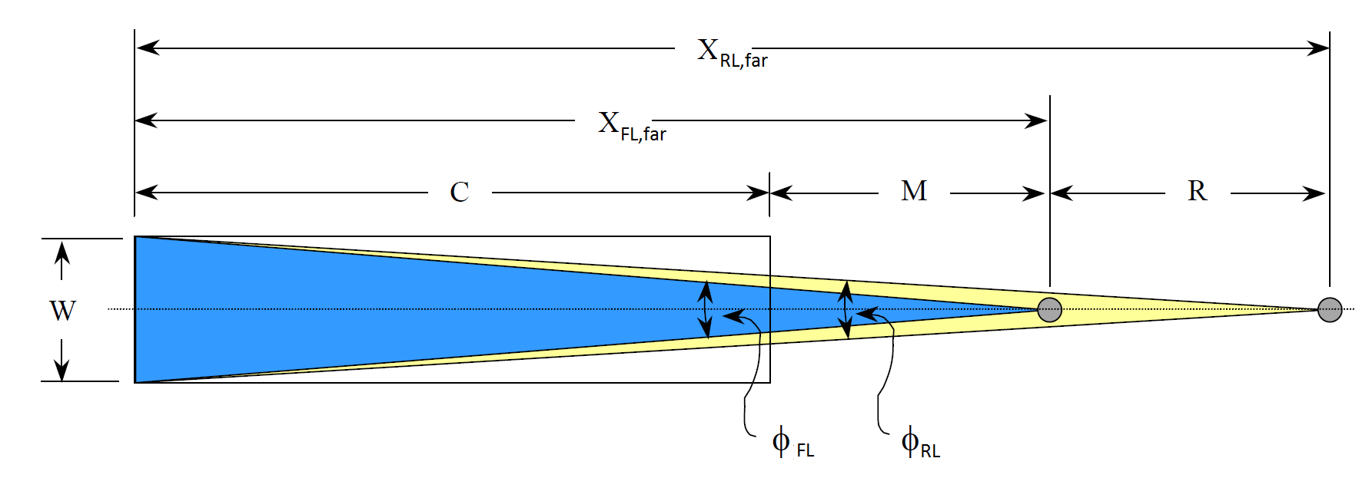

1. Beam Width of Leading Lights

The need for acquisition of the leading lights prior to turning onto a leading line should also be considered when selecting the beam width of the leading lights. In order to reach the first useful segment of the leading line it will often be necessary to observe at least one of the leading lights in a region to seaward and/or to either side of the channel. This is called the 'acquisition region'. The selected leading lights should have a beam width (and intensity) sufficient to cover the desired acquisition point.

### Additional Lights

If the design does NOT use omnidirectional optics at night, and the structure is located in navigable waters, it may be necessary to add omnidirectional lights to the structure. These additional lights should be mounted where they will not be blocked by the structure.

* Additional lights should be mounted at a low enough height to ensure that the lights will be visible to vessels with a low height of eye. As an example, if a leading line has a front tower height of 8 m and a rear tower height of 25 m, the additional light for the front tower can be mounted directly above the front leading light. The additional light should display the same characteristic as the leading light, and should be synchronized with the leading light.
* On towers greater than about 12 m, the additional lights may be designated as passing lights and installed at a lower level than the leading light. Installation of a passing light requires two optics, as the structure will partially occlude the output from each lantern. The passing lights should be mounted on opposite corners of the structure, and should be synchronized, also with the leading light.

## Daymarks versus Daytime Lights

Traditionally leading lights, particularly those powered by batteries, were switched offduring daylight, with the daytime signal provided by leading marks. Recent efficiency improvements in optics combined with solar power have allowed expanded use of daytime leading lights, even when commercial power is not readily available. The following are some points to consider when deciding on the daytime signal:

* Marks are simple. Having no moving parts they require little maintenance and so are more reliable than lights. Smaller marks are also easy to maintain, with no special training required for servicing personnel.
* Daytime leading lights provide a superior signal. In marginal conditions they can be seen further than day marks. Furthermore, substituting lights for large marks may result in less costly tower structures and foundations. Daytime lights, however, require more complex lighting and power systems, which will increase hardware costs and the technical demands on the servicing personnel. However, the higher initial equipment costs will likely be more than offset by reduced structural costs.

## Colour and Flashes

In many cases, it is advantageous to use the same colour and synchronized flashes for front and leading light of a leading line. In the presence of rival lights this will highlight that these two lights belong together. When a channel is marked by a series of leading lines in succession, each leading line should have a different flash character than the nearby ones.

Fixed (F) characteristics should be used sparingly, if at all. Lights displaying a fixed characteristic, especially white light signals, can be difficult to identify against even minimal background lighting. Furthermore, flashing lights displaying a character with a three second flash duration provide approximately 96% of the intensity of a fixed light signal, yield longer lamp service intervals, have lower power consumption, and provide greater conspicuity than the fixed light signal.

Russians also say that

If the lights are not synchronized the length of flashes and periods of the front lights should be shorter than these of the rear light.

Duration of the flashes should not be less than 0.5 s.

Length of the flashes of the rear light should be selected based on maximum overlapping of the duration of the flashes of the leading lights. The narrower the channel the more the flashes must be seen simultaneously.

## Tower Placement

Placement of the leading line structures determines the axis of the leading line. Tower placement along the centreline should be within ±3 meters of the desired position, while the lateral error in placement of the towers to either side of the true centreline should be limited to approximately ±0.3 meters. See Figure 20.

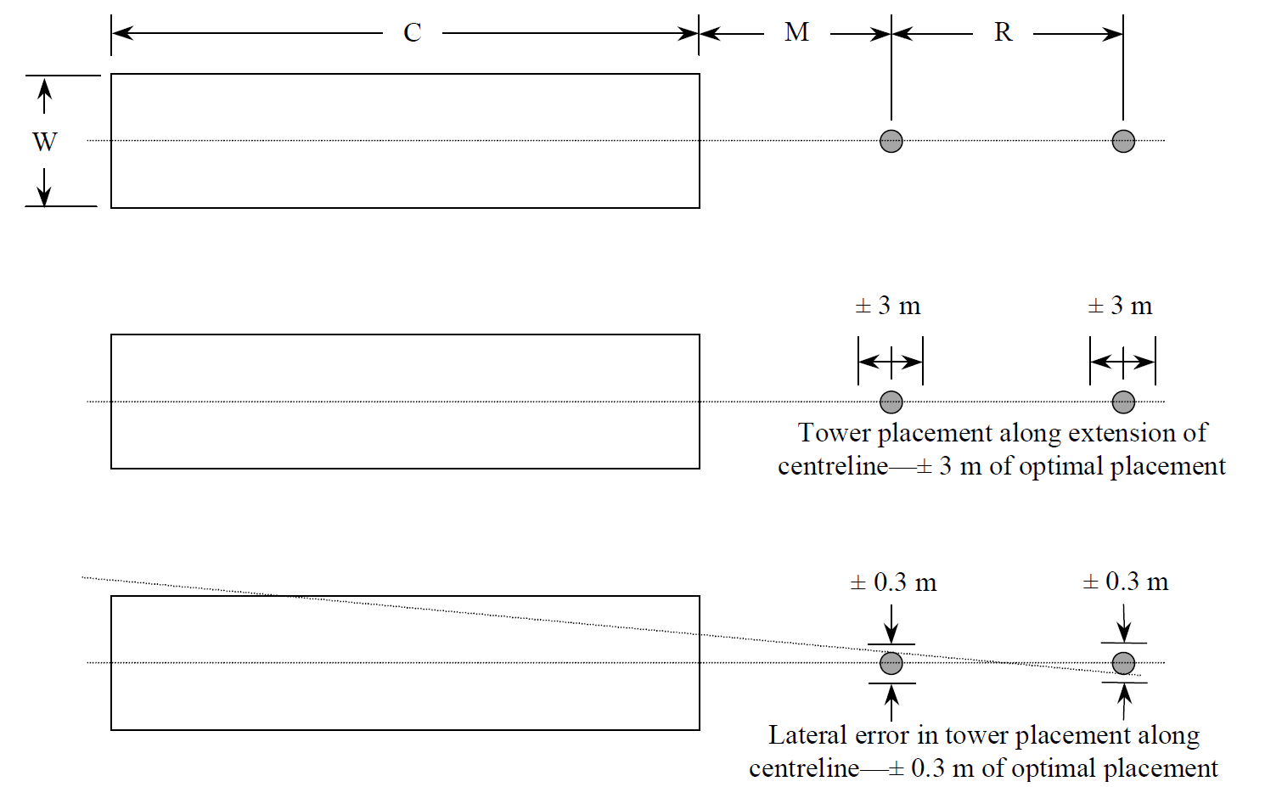

1. Tower Placement

## Lantern Placement

Proper lantern placement is necessary to ensure that blur will not occur during nighttime and that each light or group of lights will be viewed as a single source. All heights are the vertical distances from mean high water to the centreline of the optics. When using both day and night leading lights, the lower optic on the front tower and the upper optic on the rear tower should be the nighttime lights. The only exception is if the front tower uses an omnidirectional nighttime light, which should then be mounted above the daytime light(s). Multiple optics for daytime lights should be installed on a horizontal plane, and should typically not exceed three across. Horizontal separation should be kept to a minimum to be sure the lights are viewed as a point source.

## Servicing Considerations

Towers should be designed to ensure that they can be serviced safely. Since many optics are serviced from the front, there should be 0.75 m of deck space available all around the optic, to allow for easy and safe access. Additionally, lanterns should be elevated a minimum of 0.5 m off the deck. When lanterns are installed more than approximately 1.25 m above the deck, a work platform should be built into the structure to allow personnel to comfortably access the lantern. Optic support structures should take into consideration any doors or servicing hatches on the installed lanterns. Railings should be installed, where appropriate, with either careful placement to prevent obstruction of the light or removable safety chains in front of optics. Operation and maintenance guides, if prepared, should be passed to the assigned servicing unit.

## Construction Details

Boat landings should be oriented to allow easy boarding under prevailing current and wind conditions. Boarding ladders should have rail extensions to allow easy transition from the deck to the ladder. For towers in excess of 20 m height, the designer should consider installation of a stairway instead of a ladder. All-weather, hand operated winches, with covers, should be installed on the main deck containing power system equipment and on the lantern deck to facilitate easy handling of hardware. Solar panels should be installed so that access to both sides of the array are possible and shall not be shadowed by railings, antennas, towers, shelters, etc., within an arc of ± 90 degrees of panel orientation.

## Safety

Installations using large batteries should have safety covers on intercell connectors to protect from accidental shorting. Battery rooms should have servicing equipment (hydrometer, tarp for covering solar panel, etc.) and safety equipment (eye wash station, gloves, goggles, etc.) available to servicing personnel in the event they do not bring the equipment with them.

## Daymark Mounting

Daymark mountings on structures should be strong enough to secure the daymark up to the tower’s designed wind load, while allowing servicing personnel easy replacement. Daymark mountings should not exceed the tower strength (daymark mountings should fail before the structure does). Access to the daymark by ladder or platform is necessary to remove/replace fasteners. Use of day/night lights is encouraged on ranges requiring marks in excess of 3 m in length, as these marks are the most hazardous to replace.

## Sensitivity of a Leading Line

The IALA Recommendation of 1998 classified the sensitivity (precision) of a leading line into three categories. However, these categories have never been used strictly. The IALA guideline and the spreadsheet use the "Cross Track Factor" ($CTF$) instead. The $CTF$ is calculated with the formulae of the second category.

Categories:

1. The standard deviation of the bearing difference of the two lights, when the observer has the impression that the two lights are vertically in line, should be calculated using the formulae: $Θ_{Q}=max\left(Θ_{1},Θ_{2}\right)$ 
     
    (53) $$where$$ $Θ_{1}=0.05∙{10}^{-3}rad+0.038∙γ$
    for $γ≤5∙{10}^{-3} rad$; $Θ_{1}=0.1∙{10}^{-3}rad+0.028∙γ$ for $5∙{10}^{-3}<γ≤20∙{10}^{-3} rad$; and $Θ_{2}=0.07∙γ_{min}$  
    .
2. The magnitude of the minimum value of the bearing difference of the two lights, when an off-axis deviation in a definite direction is considered as detected with certainty by the observer, should calculated using the formulae: $Θ_{D}=max\left({Θ'}_{1},{Θ'}_{2}\right)$ 
     
    (54)where ${Θ'}_{1}=0.16∙{10}^{-3}rad+0.12∙γ$ 
    for $γ≤5∙{10}^{-3} rad$; ${Θ'}_{1}=0.31∙{10}^{-3}rad+0.09∙γ$ for $5∙{10}^{-3}<γ≤20∙{10}^{-3} rad$; and ${Θ'}_{2}=0.224∙γ_{min}$.
3. In the interest of safety, the axis of the leading lights be established in such a manner that for the type of ships and navigation conditions considered, the ship may safely depart from the axis up to a point where the bearing difference as observed by the navigator reaches the following value in radians: $Θ_{M}=max\left({Θ^{''}}_{1},{Θ^{''}}_{2}\right)$ 
     
    (55) $$where$$ ${Θ''}_{1}=0.25∙{10}^{-3}rad+0.19∙γ$ for $γ≤5∙{10}^{-3} rad$; ${Θ''}_{1}=0.5∙{10}^{-3}rad+0.14∙γ$ for $5∙{10}^{-3}<γ≤20∙{10}^{-3} rad$; and ${Θ''}_{2}=0.35∙γ_{min}$.

See chapter 6.5 and 6.6.

# references

1. IALA Recommendation on Leading Lights E-112, May 1998
2. IALA Guideline 1023 The Design of Leading Lines, December 2001
3. IALA Guideline G1148 - Determination of Required Luminous Intensity for Marine Signal Lights
4. Système International d'Unités (International System of Units) published by Bureau International des Poids et Mesures (International organization established by the Metre Convention), www.bipm.org
5. Regulations of the IHO for International (INT) Charts and Chart Specifications of the IHO, Edition 4.9.0, 2021
6. United States of America, US Coast Guard, Instruction M16500.4, Range Design, 1980
7. Report of the Proceedings of the International Technical Conference on Lighthouses and other Aids to Navigation , Paris 1993, published by Trinity House 1936
8. IALA Guideline 1094 Daymarks for Aids to Navigation, Edition 2.0, June 2016
9. United States Coast Guard Aids to Navigation Manual - Technical, U.S. Department of Homeland Security, Apr 06 2010

# Abbreviations and Technical Quantities

## Roman

| **Abbreviation** | **Explanation** | **Chapter** |
| --- | --- | --- |
| $$a$$ | Function for daymark size calculation | 6.10.1 |
| $$b$$ | Function for daymark size calculation | 6.10.1 |
| $$C$$ | Length of useful segment | 5.1 |
| $$CTF$$ | Cross-track factor | 6.7 |
| $$D_{index}$$ | usually a range when used with an index |  |
| $$D_{DM}$$ | Range of a daymark | 5.4 |
| $$D_{DM,FL}$$ | Range of front light daymark | 7.4.7 |
| $$D_{DM,RL}$$ | Range of rear light daymark | 7.4.8 |
| $$DTL$$ | indicates the use of daytime lights (yes/no) | 5.4 |
| $$DM$$ | indicates the use of daymarks (yes/no) | 5.4 |
| $$d_{U}$$ | unit distance ($d_{U}=1852m=1M$) | 5 |
| $$E$$ | illuminance | 5.4 |
| $$E_{FL}$$ | Illuminance at the eye of the observer by the front light | 5.3 |
| $$E_{FL,dsg}\left(x\right)$$ | Illuminance from front light, design visibility | 7.3.7 |
| $$E_{FL,max}\left(x\right)$$ | Illuminance from front light, maximum visibility | 7.3.7 |
| $$E_{FL,min}\left(x\right)$$ | Illuminance from front light, minimum visibility | 7.3.7 |
| $$E_{max}$$ | Maximum illuminance at the eye of the observer | 5.3 |
| $$E_{r}$$ | Required illuminance at the eye of the observer | 5.3 |
| $$E_{RL,dsg}\left(x\right)$$ | Illuminance from rear light, design visibility | 7.3.7 |
| $$E_{RL,max}\left(x\right)$$ | Illuminance from rear light, maximum visibility | 7.3.7 |
| $$E_{RL,min}\left(x\right)$$ | Illuminance from rear light, minimum visibility | 7.3.7 |
| $$E_{RL}$$ | Illuminance at the eye of the observer by the rear light | 5.3 |
| $$E_{U}$$ | Unit illuminance ($E_{U}=1 lx$) | 5 |
| $$E^{+}$$ | maximum illuminance at the eye either from FL or RL | 6.5 |
| $$I_{FL}$$ | Luminous intensity, front light | 5.3 |
| $$I_{RL}$$ | Luminous intensity, rear light | 5.3 |
| $$H$$ | Height | 5.4 |
| $$H_{FL}$$ | Height of front light above $MHW$ or $MSL$ | 5.2 |
| $$H_{FL,min1}$$ | Minimum height of/*or comma* front light (height above safe water) | 6.9.1.1 |
| $$H_{FL,min2}$$ | Minimum height front light daymark (height above safe water) | 6.9.1.1 |
| $$H_{FL,min3}$$ | Minimum height front light (geographical range) | 6.9.1.2 |
| $$H_{FL,min4}$$ | Minimum height front light daymark (geographical range) | 6.9.1.2 |
| $$H_{FL,min5}$$ | Minimum height front light (obstruction, far end) | 6.9.1.3 |
| $$H_{FL,min6}$$ | Minimum height front light (obstruction, near end) | 6.9.1.3 |
| $$H_{FL,min7}$$ | Minimum height front light daymark (obstruction, far end) | 6.9.1.3 |
| $$H_{FL,min8}$$ | Minimum height front light daymark (obstruction, near end) | 6.9.1.3 |
| $$H_{FL,rec}$$ | Recommended height of the front light | 6.9.1.4 |
| $$H_{FL,sel}$$ | Selected height of the front light | 6.9.1.4 |
| $H_{obs}$ | Height of an obstruction above $MHW$ or $MSL$ | 6.9.1.3 |
| $$H_{v}$$ | Height of observer (on vessel) above sea level | 5.2 |
| $$H_{RL}$$ | Height of rear light above $MHW$ or $MSL$ | 5.2 |
| $$H_{RL,min1}$$ | Minimum height rear light (blur, far end) | 6.9.2.1 |
| $$H_{RL,min2}$$ | Minimum height rear light (blur, near end) | 6.9.2.1 |
| $$H_{RL,min3}$$ | Minimum height rear light daymark (front light not obscuring, far end) | 6.9.2.3 |
| $$H_{RL,min4}$$ | Minimum height rear light daymark (front light not obscuring, near end) | 6.9.2.3 |
| $$H_{RL,min5}$$ | Minimum height rear light (obstruction, far end) | 6.9.2.4 |
| $$H_{RL,min6}$$ | Minimum height rear light (obstruction, near end) | 6.9.2.4 |
| $$H_{RL,min7}$$ | Minimum height rear light daymark (obstruction, far end) | 6.9.2.5 |
| $$H_{RL,min8}$$ | Minimum height rear light daymark (obstruction, near end) | 6.9.2.5 |
| $$H_{RL,rec}$$ | Recommended height of the rear light | 6.9.2.6 |
| $$H_{RL,sel}$$ | Selected height of the rear light | 6.9.2.6 |
| $$H_{shaw}$$ | Safe height above water | 6.9.1.1 |
| $$h_{U}$$ | Unit height $h_{U}=1 m$ | 5 |
| $$I$$ | luminous intensity | 5.4 |
| $$I_{FL,max}$$ | Maximum luminous intensity, front light | 6.2.4 |
| $$I_{FL,min}$$ | Minimum luminous intensity, front light | 6.2.1 |
| $$I_{FL,rec}$$ | Recommended luminous intensity, front light | 6.2.2 |
| $$I_{FL,sel}$$ | Selected luminous intensity, front light | 6.5 |
| $$I_{FL,max}$$ | Maximum luminous intensity, rear light | 6.2.4 |
| $$I_{FL,min}$$ | Minimum luminous intensity, rear light | 6.2.1 |
| $$I_{FL,rec}$$ | Recommended luminous intensity, rear light | 6.2.2 |
| $$I_{FL,sel}$$ | Selected luminous intensity, rear light | 6.5 |
| $$L$$ | (vertical) length, usually for the daymark | 5.4 |
| $$L$$ | Distance to front structure from far end to useful segment | 5.1 |
| $$L_{DM,rec}$$ | Recommended vertical length of a daymark | 6.10.1 |
| $$L_{FL,DM}$$ | Vertical length of the front light daymark | 5.2 |
| $$L_{FL,DM,rec}$$ | Recommended vertical length of the front light daymark | 7.3.1 |
| $$L_{FL,DM,sel}$$ | Selected vertical length of the front light daymark | 6.9.1.1 |
| $$L_{RL,DM}$$ | Vertical length of the rear light daymark | 5.2 |
| $$L_{RL,DM,sel}$$ | Selected vertical length of the rear light daymark | 6.9.1.1 |
| $$L_{RL,DM,rec}$$ | Recommended vertical length of the rear light daymark | 7.3.1 |
| $$M$$ | Distance to front structure from near end to useful segment | 5.1 |
| $$M_{initial}$$ | Initial value of $M$ for iteration process | 6.1 |
| $$MHW$$ | Mean high water | 5.2 |
| $$MLW$$ | Mean low water | 5.2 |
| $$MSL$$ | Mean sea level | 5.2 |
| $$MTR$$ | Mean tidal range | 5.2 |
| $$R$$ | Distance between leading line structures | 5.1 |
| $$R_{initial}$$ | Initial value of $R$ for iteration process | 6.1 |
| $$R_{g}$$ | geographical range | 5.4 |
| $$r$$ | ratio of intensities | 5.4 |
| $$r_{1}$$ | ratio of intensities, first value | 6.2.2 |
| $$r_{2}$$ | ratio of intensities, second value | 6.2.2 |
|  |  |  |
| $$S$$ | distance between an obstruction and front light | 5.4 |
| $$V$$ | visibility | 5.4 |
| $$V_{dsg}$$ | Design Meteorological visibility | 5.3 |
| $$V_{max}$$ | Maximum Meteorological visibility | 5.3 |
| $$V_{min}$$ | Minimum Meteorological visibility | 5.3 |
|  |  |  |
| $$W$$ | Channel width | 5.1 |
| $$W_{index}$$ | (horizontal) extension or width when used with index |  |
| $$W_{DM,rec}$$ | Recommend width of a daymark | 6.10.1 |
| $$W_{FL,DM,rec}$$ | Recommend width of front light daymark | 7.3.1 |
| $$W_{RL,DM,rec}$$ | Recommend width of rear light daymark | 7.3.1 |
| $$x$$ | Distance of observer (vessel) from front tower | 5.1 |
| $$X_{FL,mid}$$ | Distance front light to middle of channel | 6.2.2 |
| $$X_{FL,far}$$ | Distance front light to far end of channel | 6.2.2 |
| $$X_{RL,mid}$$ | Distance rear light to middle of channel | 6.2.2 |
| $$X_{RL,far}$$ | Distance rear light to near end of channel | 6.2.2 |
| $$y$$ | Distance of observer from centerline of channel | 5.1 |
| $$Y_{D}$$ | Sensitivity type D | 6.7 |
| $$Z$$ | dip of horizon | 5.4 |
| $$Z_{FL}$$ | Dip of horizon at front light | 5.2 |
| $$Z_{RL}$$ | Dip of horizon at rear light | 5.2 |
|  |  |  |

## Greek

| **Abbreviation** | **Explanation** | **Chapter** |
| --- | --- | --- |
| $$α$$ | factor for calculation of dip of horizon ($α=6.75*{10}^{-8}m^{-1}$) | 5.4 |
| $$ϕ$$ | angle used to describe horizontal divergence | 5.4 |
| $$θ$$ | Bearing difference | 5.1 |
| $$Θ_{D}$$ | Bearing difference for sensitivitySensitivity type D (category 2) | 6.6 |
| $$Θ_{M}$$ | Sensitivity type M (category 3) | 8.10 |
| $$Θ_{Q}$$ | Sensitivity type Q (category 1) | 8.10 |
| $$θ_{FL}$$ | Bearing front light | 6.4 |
| $$θ_{RL}$$ | Bearing rear light | 6.4 |
| $$Θ_{1}$$ | Partial result sensitivity type Q (category 1) | 8.10 |
| $$Θ_{2}$$ | Partial result sensitivity type Q (category 1) | 8.10 |
| $${Θ'}_{1}$$ | Partial result sensitivity type D (category 2) | 6.6 |
| $${Θ'}_{2}$$ | Partial result sensitivity type D (category 2) | 6.6 |
| $${Θ''}_{1}$$ | Partial result sensitivity type M (category 3) | 8.10 |
| $${Θ''}_{2}$$ | Partial result sensitivity type M (category 3) | 8.10 |
| $$γ$$ | Elevation difference | 5.2 |
| $$γ_{FL}$$ | Elevation front light | 6.3 |
| $$γ_{min}$$ | Minimum elevation difference | 6.5 |
| $$γ_{RL}$$ | Elevation rear light | 6.3 |

1. SIMPLIFIED INTENSITY CALCULATION
   1. Introduction

The minimum required luminous intensity $I_{min}$ of a marine signal light was traditionally calculated with the Allard's law (see IALA Guideline G1148 [1]).

* $I_{min}=E_{min}∙{d_{max}}^{2}∙{0.05}^{-\frac{d_{max}}{V_{min}}}$ (A1)

where:

$I_{min}$ is the minimum required intensity (cd);

$E_{min}$ is the minimum required illuminance at the eye of the observer (lx);

$d_{max}$ is the distance of farthest point of the useable range to the AtoN light (m); and

$V_{min}$ is the minimum meteorological visibility in the area of interest (m).

The minimum required illuminance at the eye of the observer was standardized to $E_{min}=2∙{10}^{-7}lx$ in 1933 at an international conference [7]. This illuminance value is linked to the physiological threshold of human eye and leads to very little intensities for short ranges. For example, a light with a range of $2 M$ and a minimum visibility of $V_{min}=10 M$ would get an intensity of only.

* 1. required intensity of Leading Lights

It was commonly accepted that to ensure their usability?lights of leading lights should be much more intense than the all other lights and therefore the minimum required illuminance for leading lights was increased five times to $E_{min}\left(leading line\right)={10}^{-6}lx$ by IALA?. This value was introduced in the Recommendation E‑112 in 1998 [1].

With this convention the required minimum intensity for leading lights (black curve inline at Figure 21) becomes five times higher than the other lights (blue curve inline at Figure 21).



1. Required intensities when calculated with different input for V and E

In addition, to provide for worse visibilityweather, it is always possible / it may/would be prudent? to choose a minimum visibility lower than $10 M$, which will increase the required intensity as well. This is shown in Figure 21 with a visibility of (red curve inline at Figure 21).

When the IALA Guideline was developed in 2001, it was recognized that all these measures in calculations / the /methodology? were not enough to represent all? the existing lights, which have been proven to provide suitable intensities for decades. The calculated minimum required intensities in the ranges about $4 000 m$ and $7 000 m$ were still below $1 000 cd$, but existing lights for these ranges were found to be about $10 000 cd$ or even $100 000 cd$.

To solve this problem a new value called 'recommended intensity' was introduced in the IALA Guideline 2001. This recommended intensity is ten times the minimum value (Figure 22).



1. Recommended Intensity for a meteorological visibility $V_{min}=10 M$ (red dotted line)
   1. IALA Guideline G1148

An alternative procedure to get suitable values for the required or recommended luminous intensity is available in IALA Guideline G1148 [3], which presents measures for situations wherewhen background illumination and rivals lights have to be considered. The guideline proposes/recommends the minimum required illuminance value ${10}^{-5}lx$ (factor 10) for minor and ${10}^{-4}lx$ (factor 100) for considerable background lighting. Both were already introduced in the 2001 IALA Guideline on leading lines. Guideline G1148 also presents the option to calculate the factor for / the effect of background illumination based on measurement of it.

Applicationapplication of Guideline G1148 requires more work on identifying the background illumination and the rival lights. This is necessary, when problems concerning the visibility of marine signal lights have been reported and there is a need of action.

* 1. Simplified Method

The German Administration investigated its exiting leading lights and found that all methods, which still have the Allard's Law as a basis, do not really represent the actual correlation between required ranges of lights and the intensities used on them (shown with blue dashed line in Figure 23) which havethat has caused no problems/complaints from users and seems to work fine .



1. Luminous intensity of German leading lights

For short range lights the actual intensity is much higher than the ones calculated according to '2001 IALA Guideline', even when the minimum visibility is about 4 M (① in Figure 23). In these cases the lights are very often nearby a harbour or a city with a lot of background illumination and rival lights.

For long range lights the existing intensities are below the values calculated according to '2001 IALA Guideline' (②in Figure 23). Background illumination and rival lights do not play an import role in these cases, but instead glare at near end of useful segment and high costs are relevant.

Based on the existing lights, a simplified empirical equation for determining recommended luminous intensity for leading lights was be derived.

* $I_{rec,sim}=I_{rec,M}∙{\left(\frac{X_{Far}}{d_{U}}\right)}^{3}$ (A2)

where:

$I_{rec,M}=1000 cd$ (recommended luminous intensity for $X_{Far}=1852 m=1 M$); and

$d_{U}=1852 m=1 M$ (unit distance).

There is some arbitrariness in this this equation and the coefficients were chosen to keep the equation simple, but it corresponds very well to existing German leading lights.

The calculation is done for the front light and the rear light intensity is harmonized with thatit using the 'illumination ratio calculation' of the '2001 IALA Guideline'.

The equation does not require selecting a meteorological visibility or estimatingestimate background illumination or rival lights. However, the resulting intensities have been proven acceptable for decades and they include background illumination and rival lights indirectly. A curve for recommended intensity according to the simplified method (blue curve) is shown in Figure 24.

When the simplified intensity calculation does not give suitable intensities and problems have been reported, it is advised to use the methods of IALA Guideline G1148 [3].



1. Recommended luminous intensity according to the simplifiedsimple method shown with blue curve… anything about the other curves, to text or in here?